Boromir`s Last Stand (TMG Battle Report):

Merry gasped in sudden shock and horror: “Orcs! Dozens of them, coming out of the trees. Oh quickly Boromir, sound your Horn and warn the others.”

Pippin teeth chattered nervously, and the small Hobbit moved involuntarily closer to their tall companion for protection.

The Gondor man quickly surveyed the scene, pursing his lips in brittle resignation of their plight. But when he spoke, his voice was calm and steady:“Get behind me… both of you… draw you swords and prepare to defend yourselves”

Boromir put the large hunting horn (that he always carried at his side) to his lips and blew a long, powerful note into the air. The lead most Orcs faltered for a moment, dismayed by the brave and hopeful tones of the war instrument; but slowly, at first… then more assuredly, they advanced on their prey.
*** *** ***
Pretty straight forward scenario: The scene (from the book and film) where Boromir, Merry and Pippin get cornered by Orcs whilst searching for the missing Frodo. The game will be fought on the Starter Set map, using the road side – as indicated on the photo below.

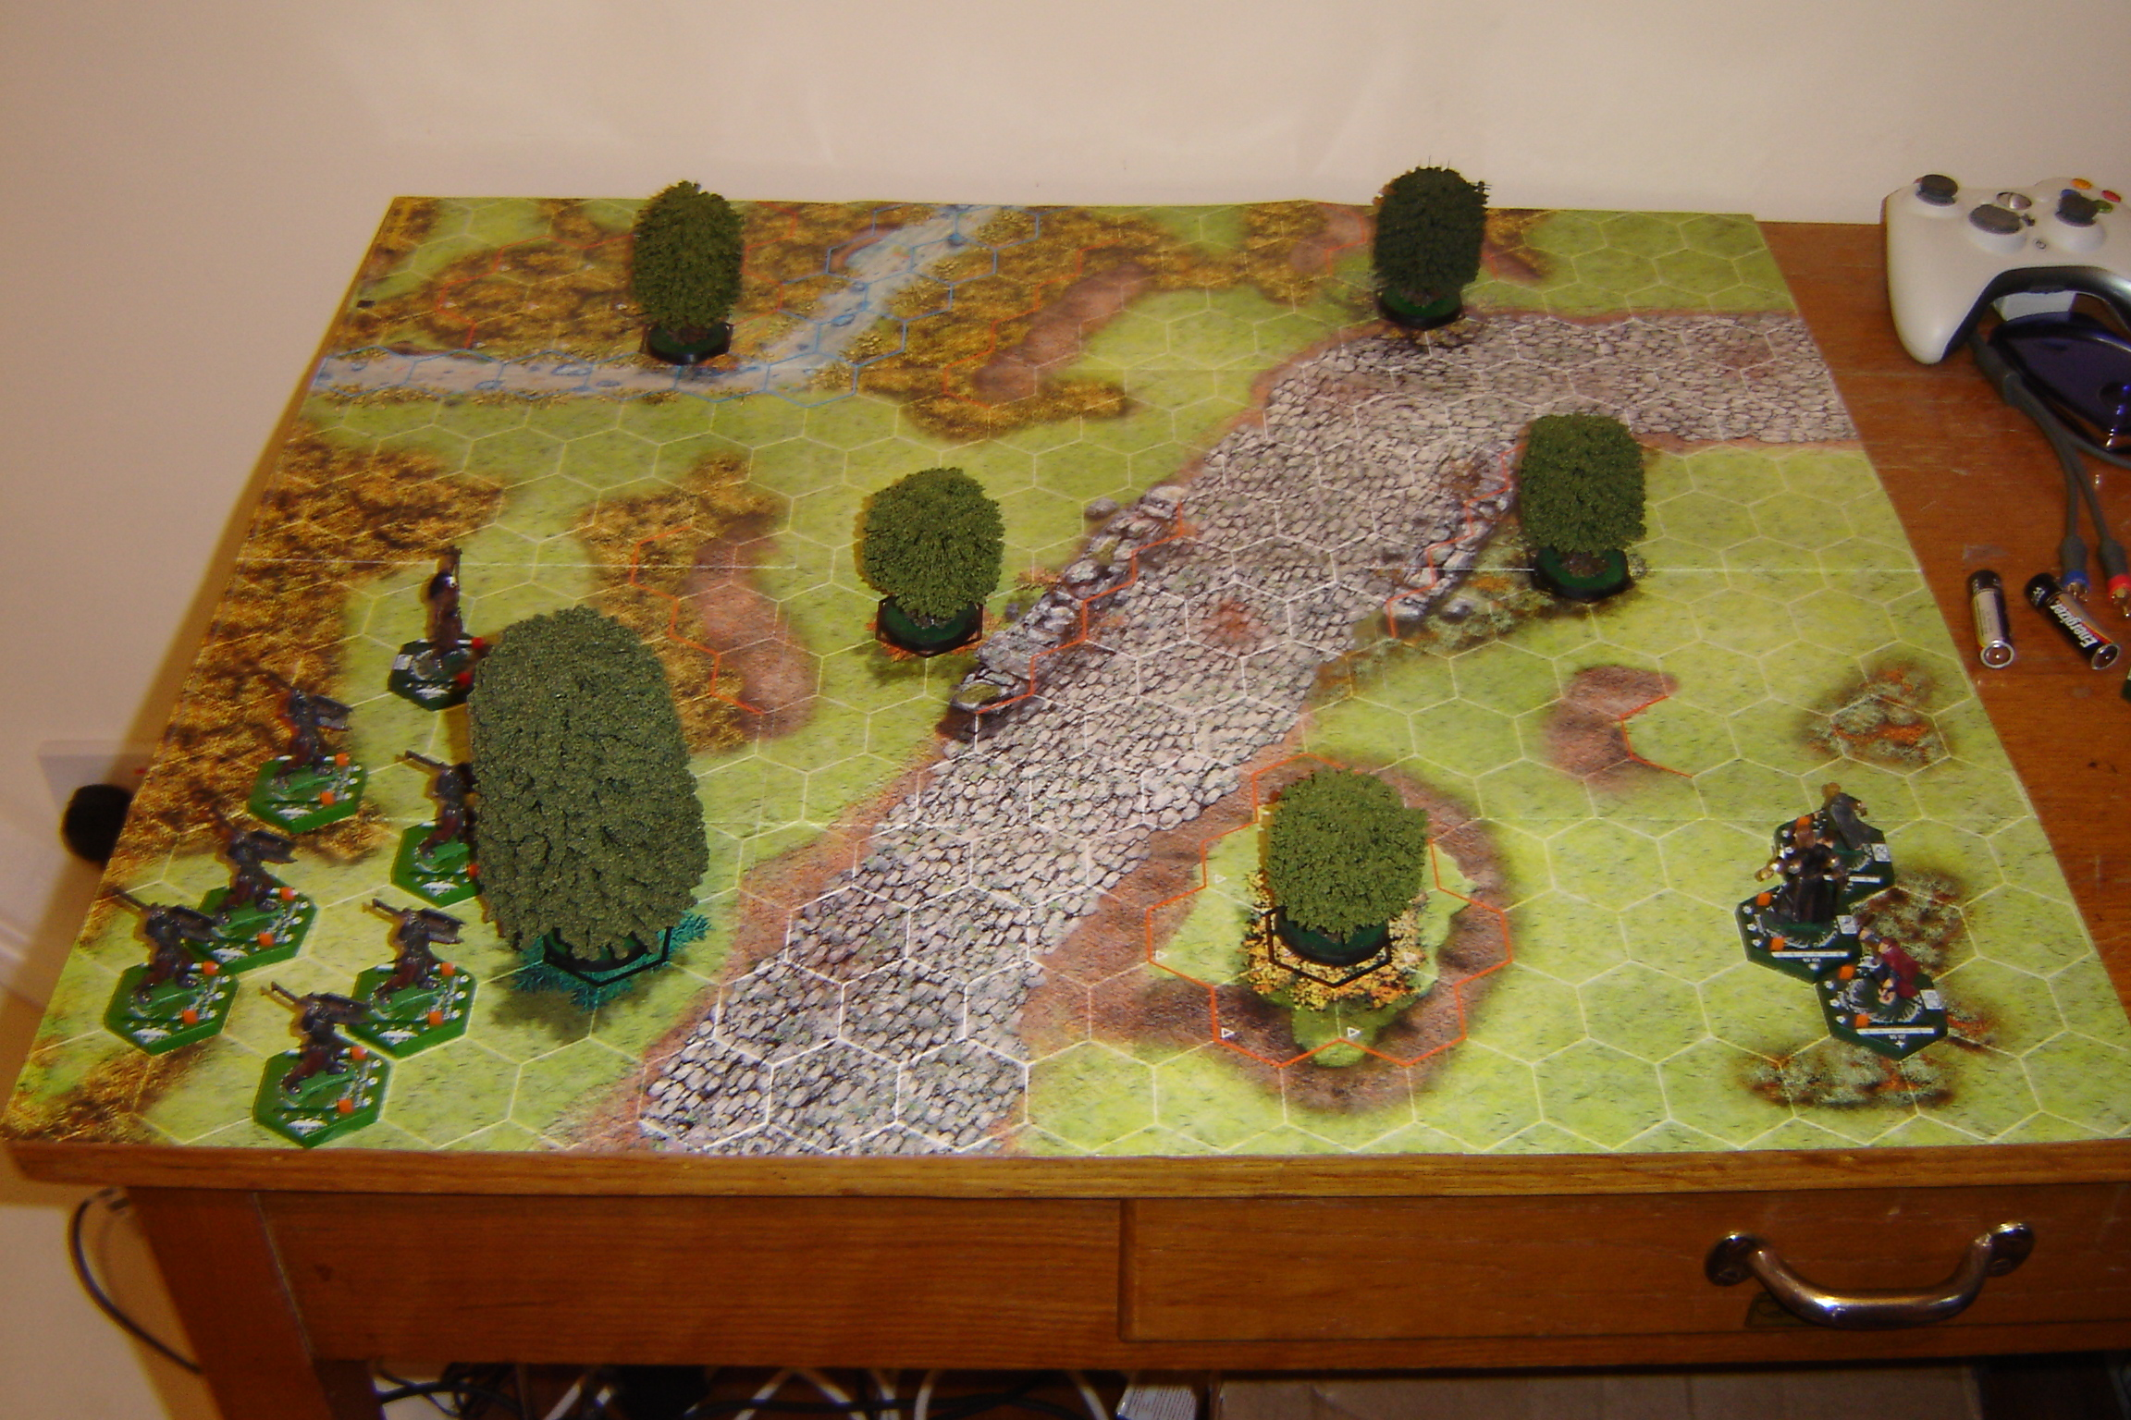
Initially, Boromir, Merry and Pippin (all orange bases) will take up position on the bottom right of the map. Opposing them will be half a dozen (orange based) Uruk Hai Warriors plus Lurtz (red): these will set up on the bottom left portion of the map.

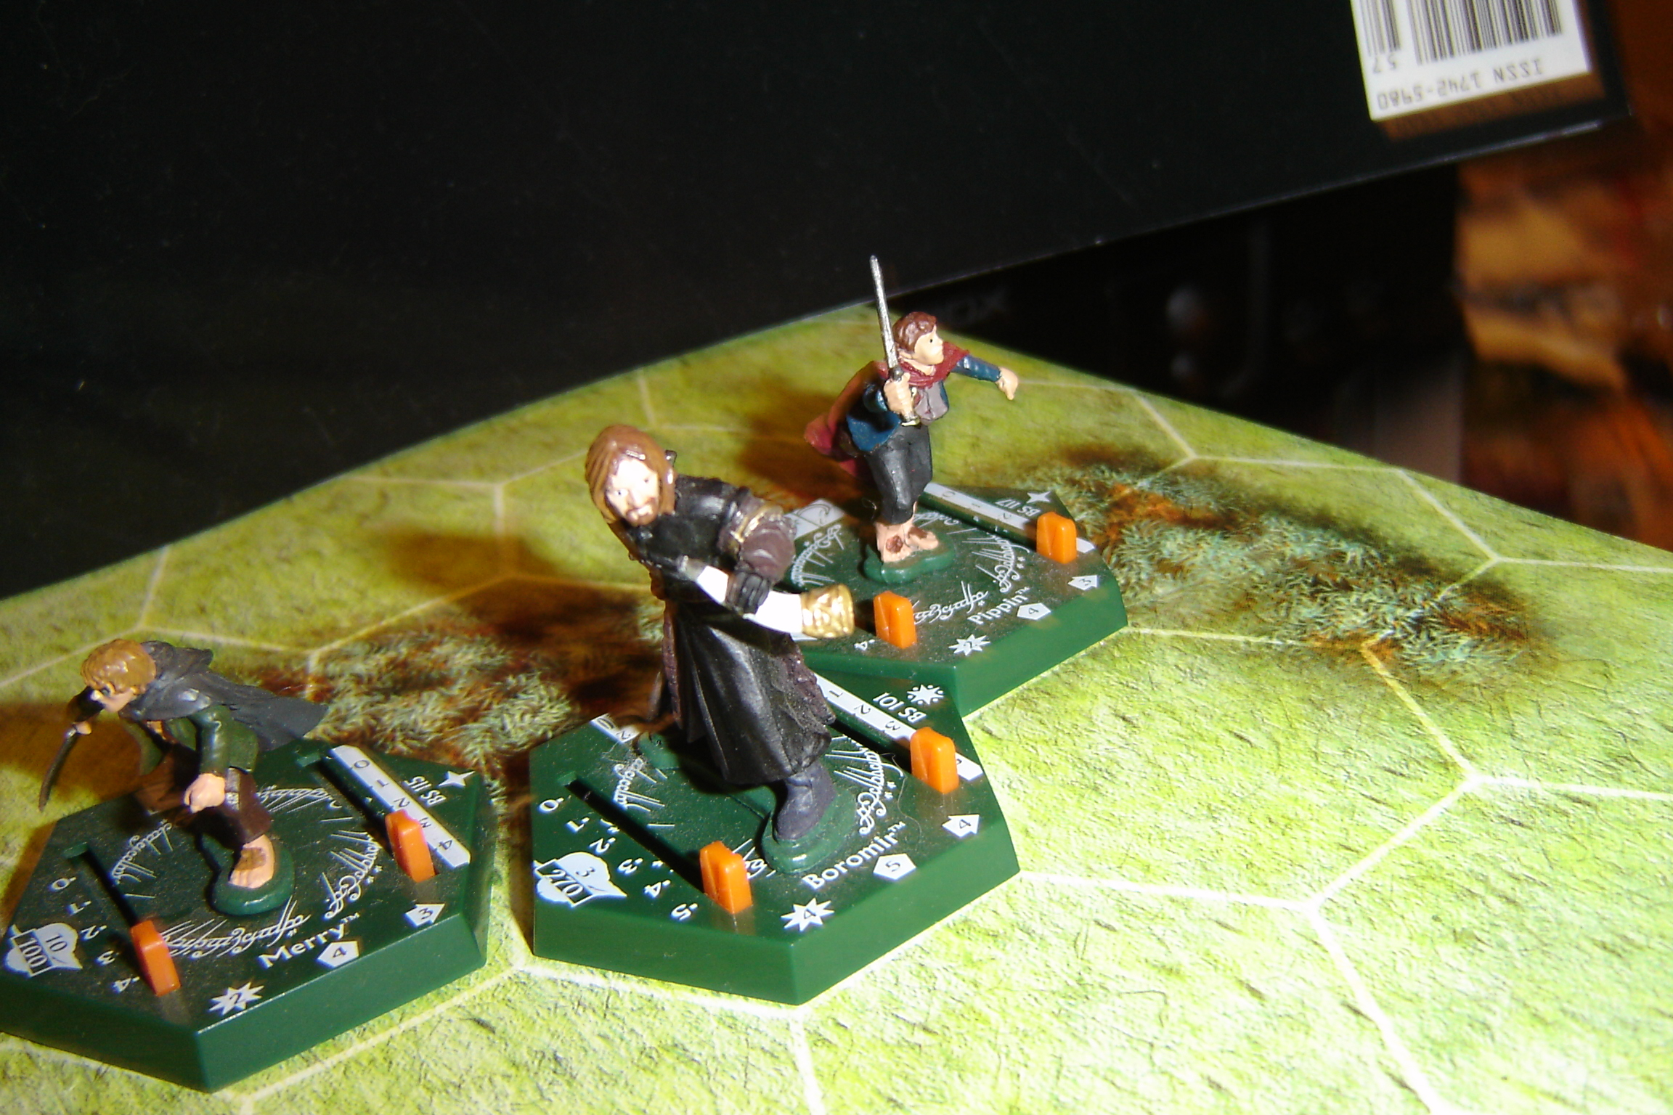
Boromir, Merry and Pippin.

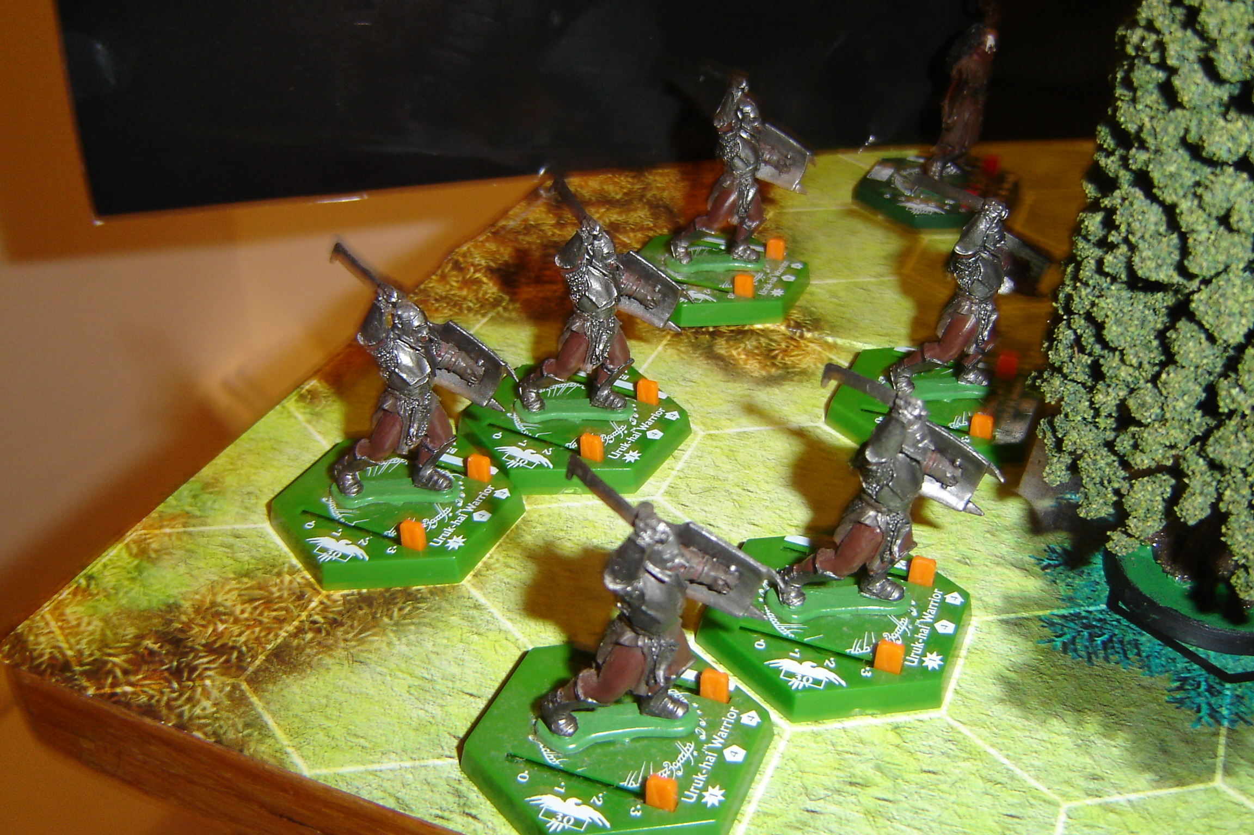
Lurtz leads the first wave of Orcs.
On move 3 at the beginning of the Fellowships Action Phase Aragorn (red) will arrive – in any hex on the far side of the water.

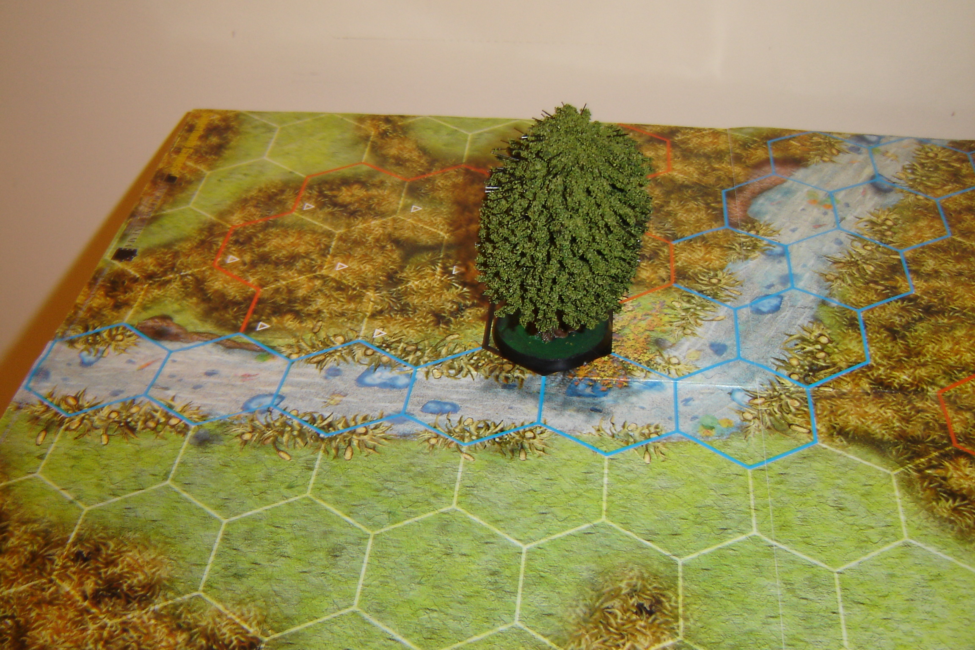
Aragorn`s game entry point – over the water.

On move 4 during the enemy`s Action Phase The Orc Champion (red) and an Uruk Hai Warrior (orange) will arrive on the road edge on the right hand side of the map.

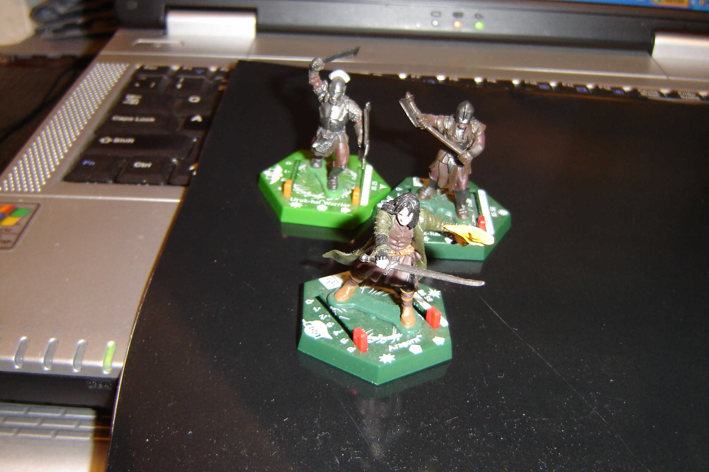
Aragorn, Champion and a Uruk Hai Warrior.
On move 6 during the Fellowship`s Action Phase Legolas and Gimli will arrive from the edge of the map - on any hex that is not within 6 hexes of an enemy miniature. On the same move, the Cirith Ungol mob (purple), two Uruk Hai Warriors (orange), and the Uruk Hai Crossbowman will arrive anywhere along the left map edge.

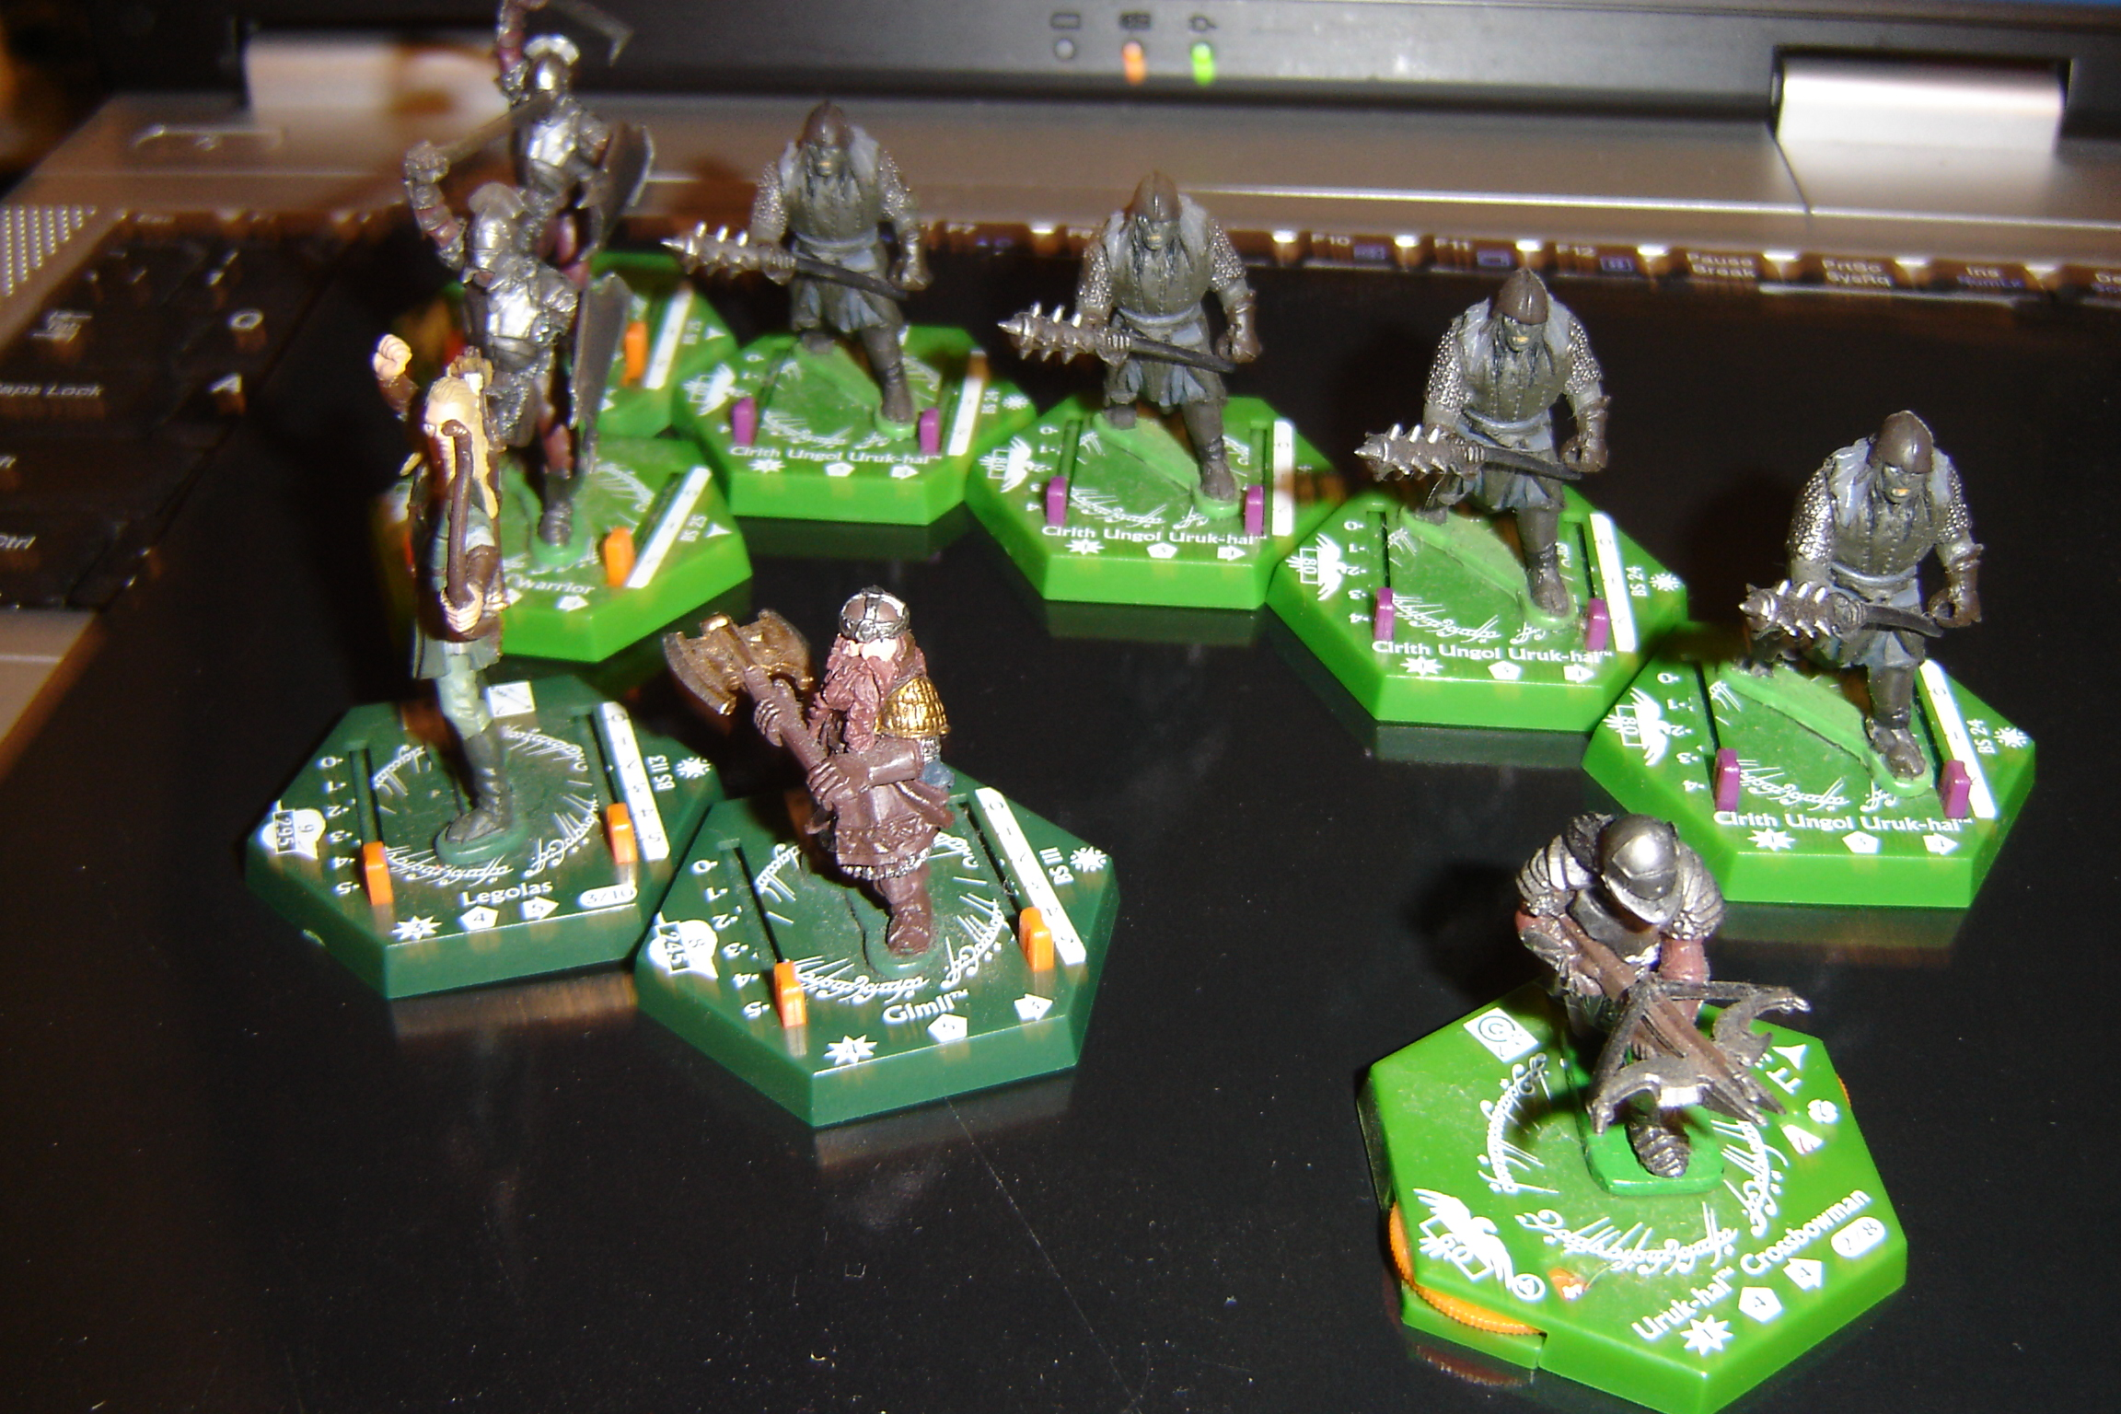
Legolas, Gimli, and the rest of the Orcs.

The points value is roughly 1400 each side (I calculated initially, but can`t be fussed to do it again now. Suffice to say, both sides are evenly matched).

Victory Conditions – The Fellowship wins by still having at least one Hobbit still alive and un-captured at the end of move 12. The Enemy wins by killing both Hobbits (In this scenario, Hobbit kills represents being captured by the Orcs).

Move 1: Enemy 5. Fellowship 1. First Move falls to Lurtz`s boys, who start to advance steadily when they spot their foe. “Find the Halflings.” The Orc leader growls.

The Fellowship responds by moving crab like a few hexes to their left to take advantage of a small hillock; this will afford a +1 dice advantage in combat (for Boromir) against any frontal attack.

Move 2: Enemy 5. Fellowship 3. Lurtz is still out of range with his bow by one hex and moves forward with the rest of his troops. He nonchalantly notches an arrow to his bow - ready for next move.

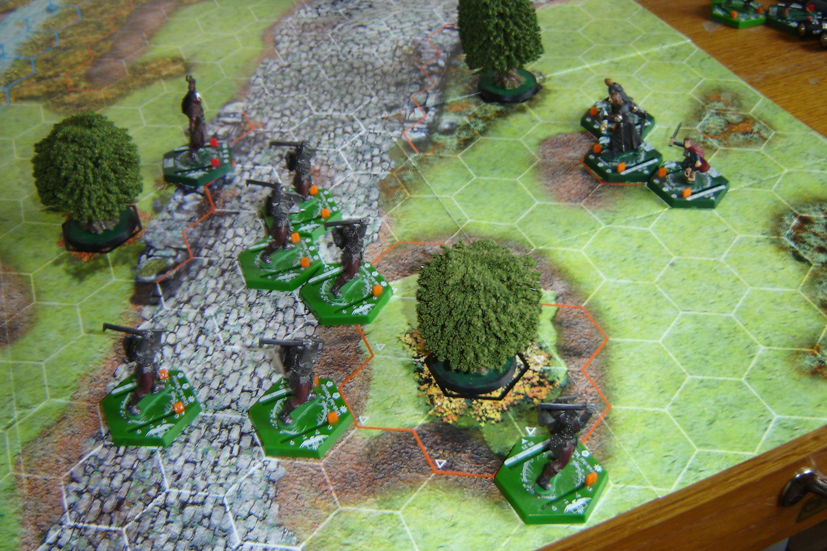

Boromir and the two Hobbit companions hold their ground defiantly. Boromir puts his hunting horn to his lips and blows a long clear blast… like a beacon on the hill for the rest of the Fellowship to come to his aid.

Move 3: Fellowship 4. Enemy 3. Aragorn bounds onto the map, and splashes clumsily across the stream towards his endangered friends.

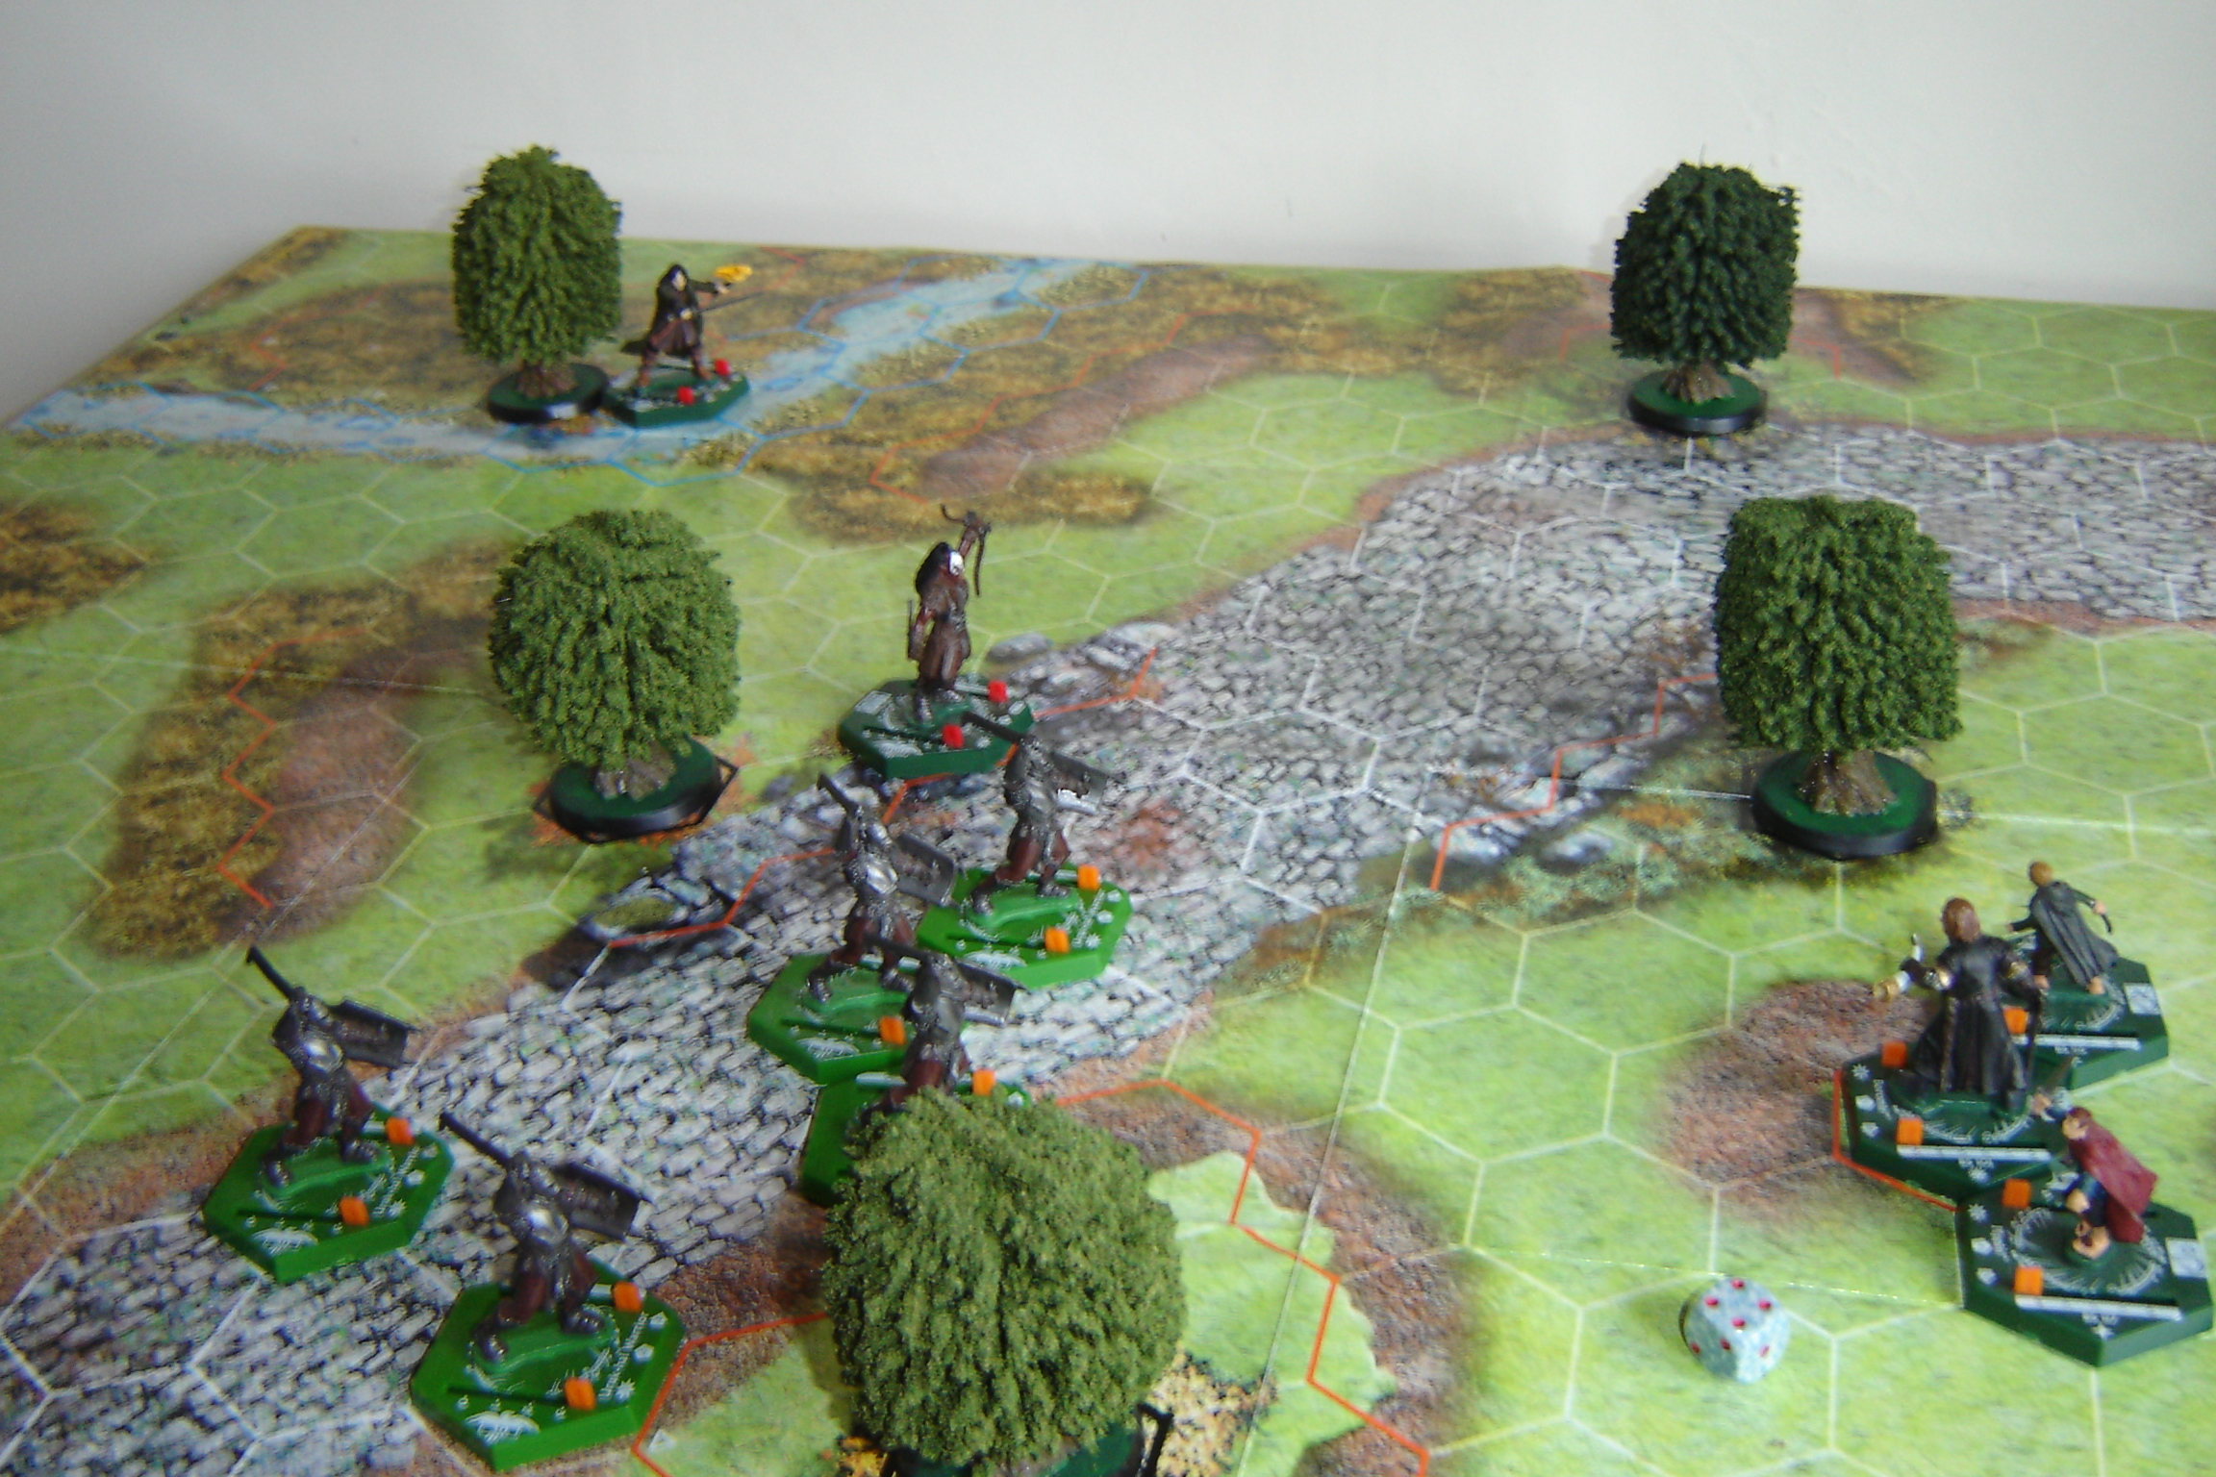
Lurtz lets an arrow fly from his bow - straight at Boromir. It whizzes past his shoulder… missing the Gondor man be a mere couple of inches.

The Orcs crash headlong into the three beleaguered companions two Uruks have to use run to ensure making contact this move.

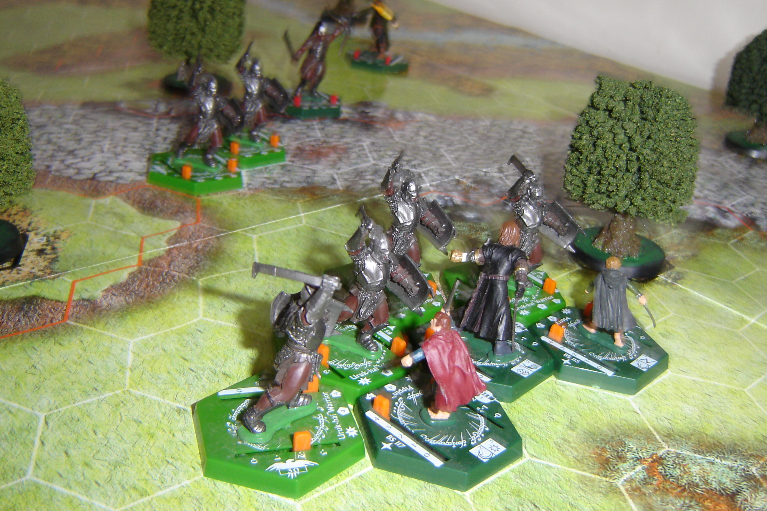

During the Close Combat Phase, the Orcs manage to achieve 4 attack dice, but none of them succeed in damaging their Fellowship targets. On the other hand, Boromir`s height advantage (+3 for having three enemies on lower ground within his kill zone), plus his Battle Cry (+1 to the each Hobbits` own attack) results in a 13 dice damage chain. 2 Orcs fall dead, and a third in wounded.

Move 4: Fellowship 5. Enemy 1 +1 for the Uruk Hai Champion) = 2.

Aragorn charges into Lurtz…. a mighty fight is about to begin there.

Boromir, Merry and Pippin stand their ground another turn… encouraged by the result of their first round of combat.

Both remaining engaged Orcs dis-engage from combat one takes a wound from Pippin`s free attack of opportunity, come round and re-engage on Pippin’s flank and rear. Another pair of Orcs run up… one engages Merry, the other joins the fight against Pippin. Boromir is left alone for the time being.

The Uruk Hai Champion and Warrior newly arrived on the map, rush towards Lurtz, eager to aid their leader against the Ranger he seems to be bloodily engaged with.

Over in the middle of the map, Aragorn fails to find a weakness in Lurtz`s defences; however, the foul Uruk slashes Aragorn and inflicts a single wound on him.

Merry holds his own against his lone assailant, and deals out a wound of his own. The Orc swings wide and misses the Hobbit entirely. Pippin does not do so well: fear, outnumbered three to one, and perhaps less skilled than his cousin – he fails to find a target for his blade, but is banged on the head three times by the enemy’s weapons. He hovers just one point above losing consciousness and becoming a prisoner.

Move 5: Fellowship 6. Enemy 4 +1 = 5. Pippin uses sneak to dis-engage from the enemy and wheels away from immediate danger. Merry, seeing his friend is in trouble… breaks free from his own combat narrowly missing taking damage himself from an Orc free attack of opportunity and engages Pippin’s enemy, thereby blocking the Orcs from following up on the wounded Hobbit next move. Boromir follows Merry into the fight.

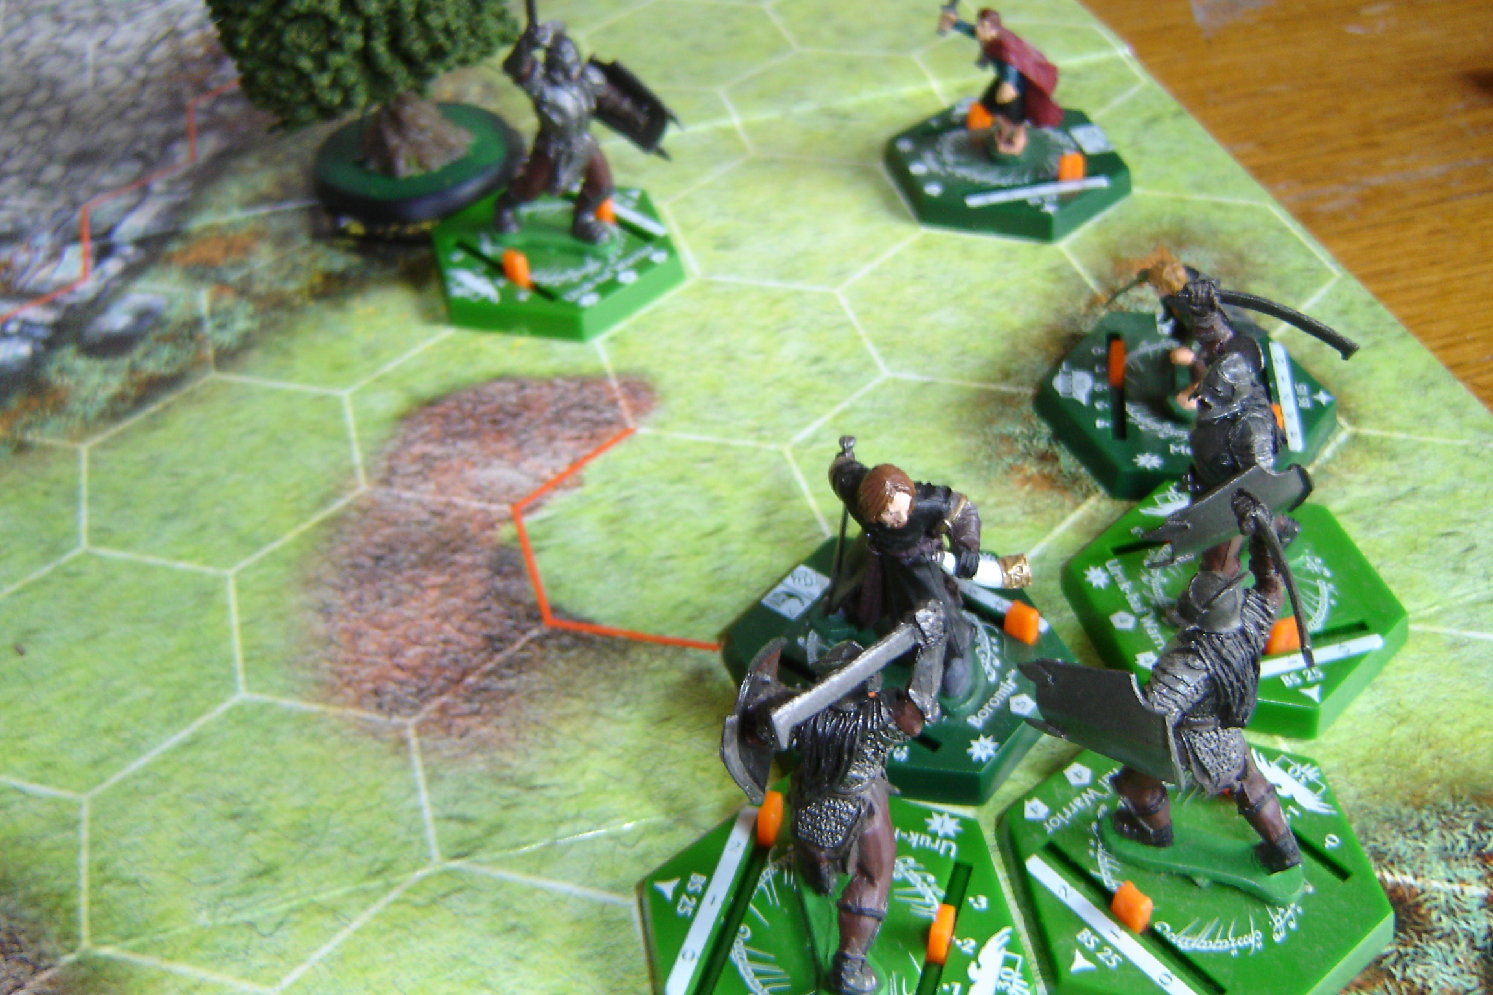
Pippin is wounded, alone and in danger... despite his friends trying to cover his back.

But Pippin is still in danger from the lone Orc Merry was formerly engaged with in Close Combat. Yet should the Orc attack Hobbit, the odds are 1 on 1 – still better than 3 to1 though. Of course, the Orc sees his chance, and rushes poor Pippin head on.

Aragorn, seeing he is about to be outflanked by the newly arrived Uruk Champion and Warrior, tears himself free from Lurtz who amazingly fails to hit the Ranger as he disengages and wheels tightly… placing himself closer to his companions, whilst putting some distance between himself and his immediate enemy. Lurtz merely grows, displays a wicked grin… and shoots an arrow at Aragorn - which catches him high in the shoulder, inflicting a second wound on then mighty warrior.

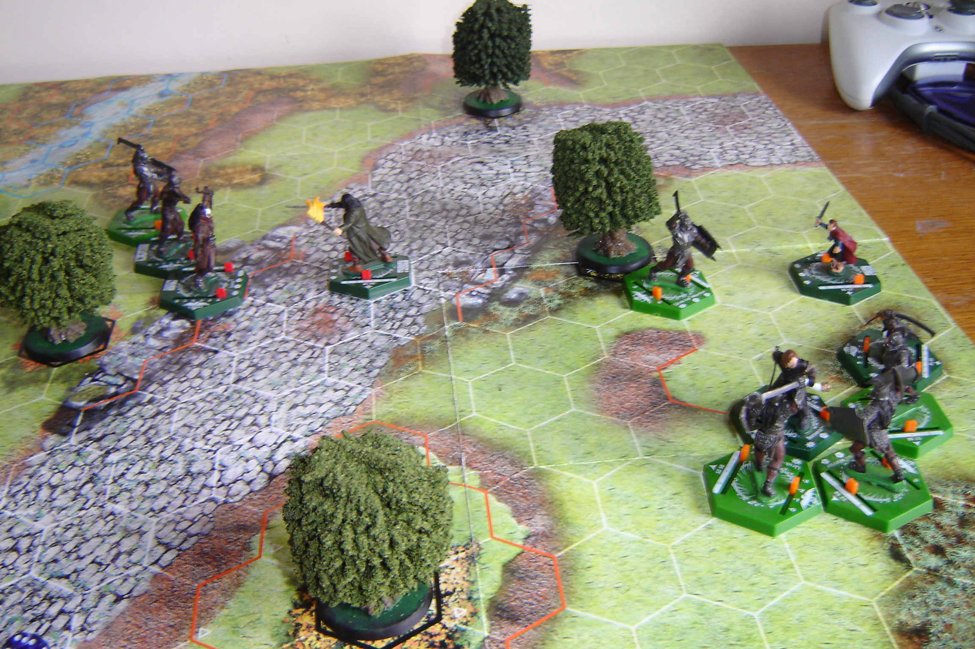
Just before the Combat Phase – Move 5.

In close combat, Pippin dispatches the Orc with ease, scoring 2 wounds on the foul smelling creature. In return the Orc hits with a 4 – then throws a 1 a critical hit. With his dying breath the Orc pays the two Action Points, and converts the critical hit into a wound! Pippin is knocked on the head once more, and lies unconscious on the ground.

Meanwhile, Boromir and Merry dispatch two more Orcs (but Boromir has now used up his last Action Points converting glancing blows and critical hits; and Merry only has one Action Point of his own remaining).

By the end of Move 5, we can see the Enemy has lost 5 orange based Uruks. The Fellowship has lost Pippin. If the Fellowship can drive the enemy away… or kill them all by the end of move 12, Pippin may still be recovered - victory for either side is as of yet still in the balance.

Move 6: Enemy 6+1 =7. Fellowship 5. Lurtz, the Champion, and the Warrior minion circle Aragorn, and move in for the kill.

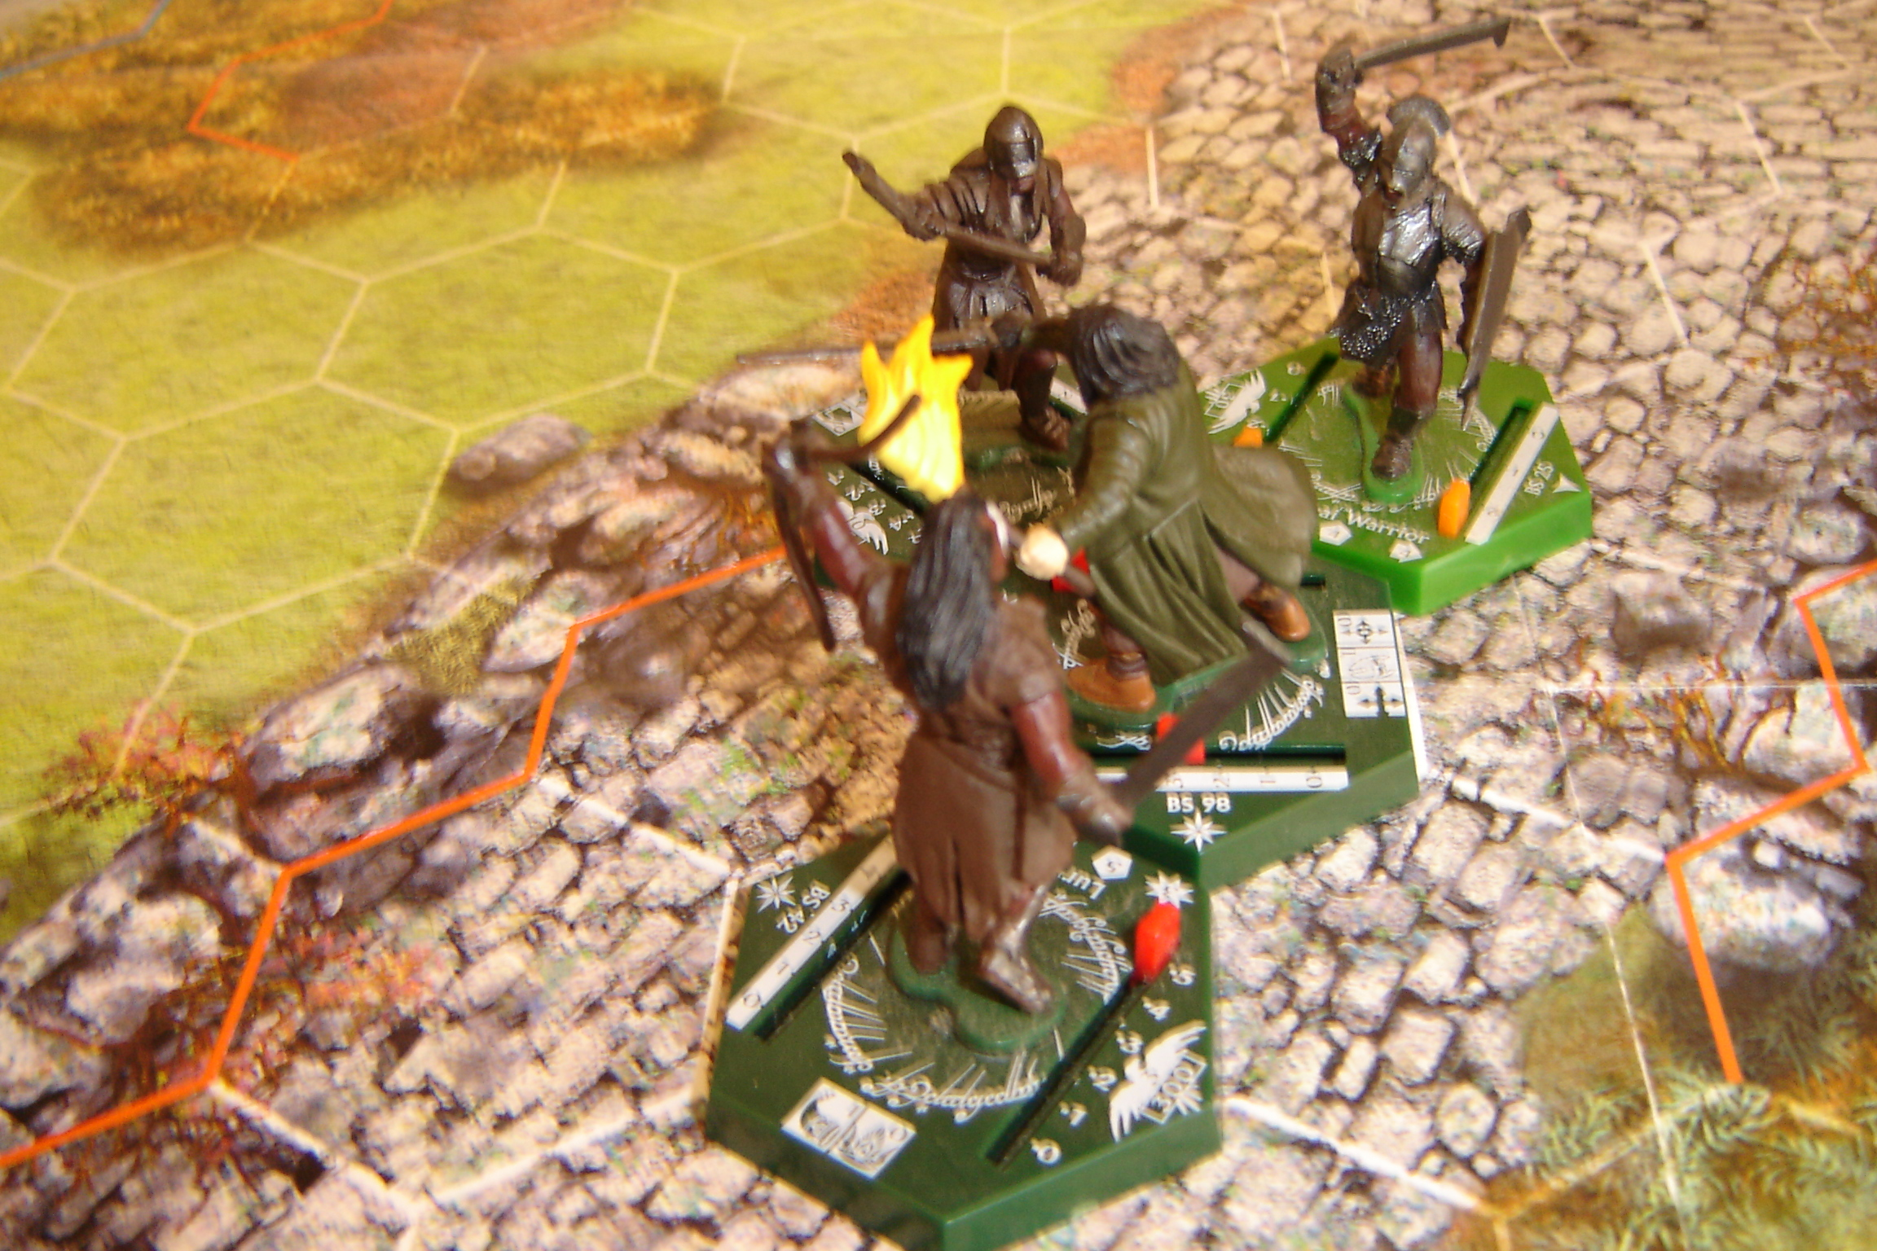
Aragorn is in trouble.
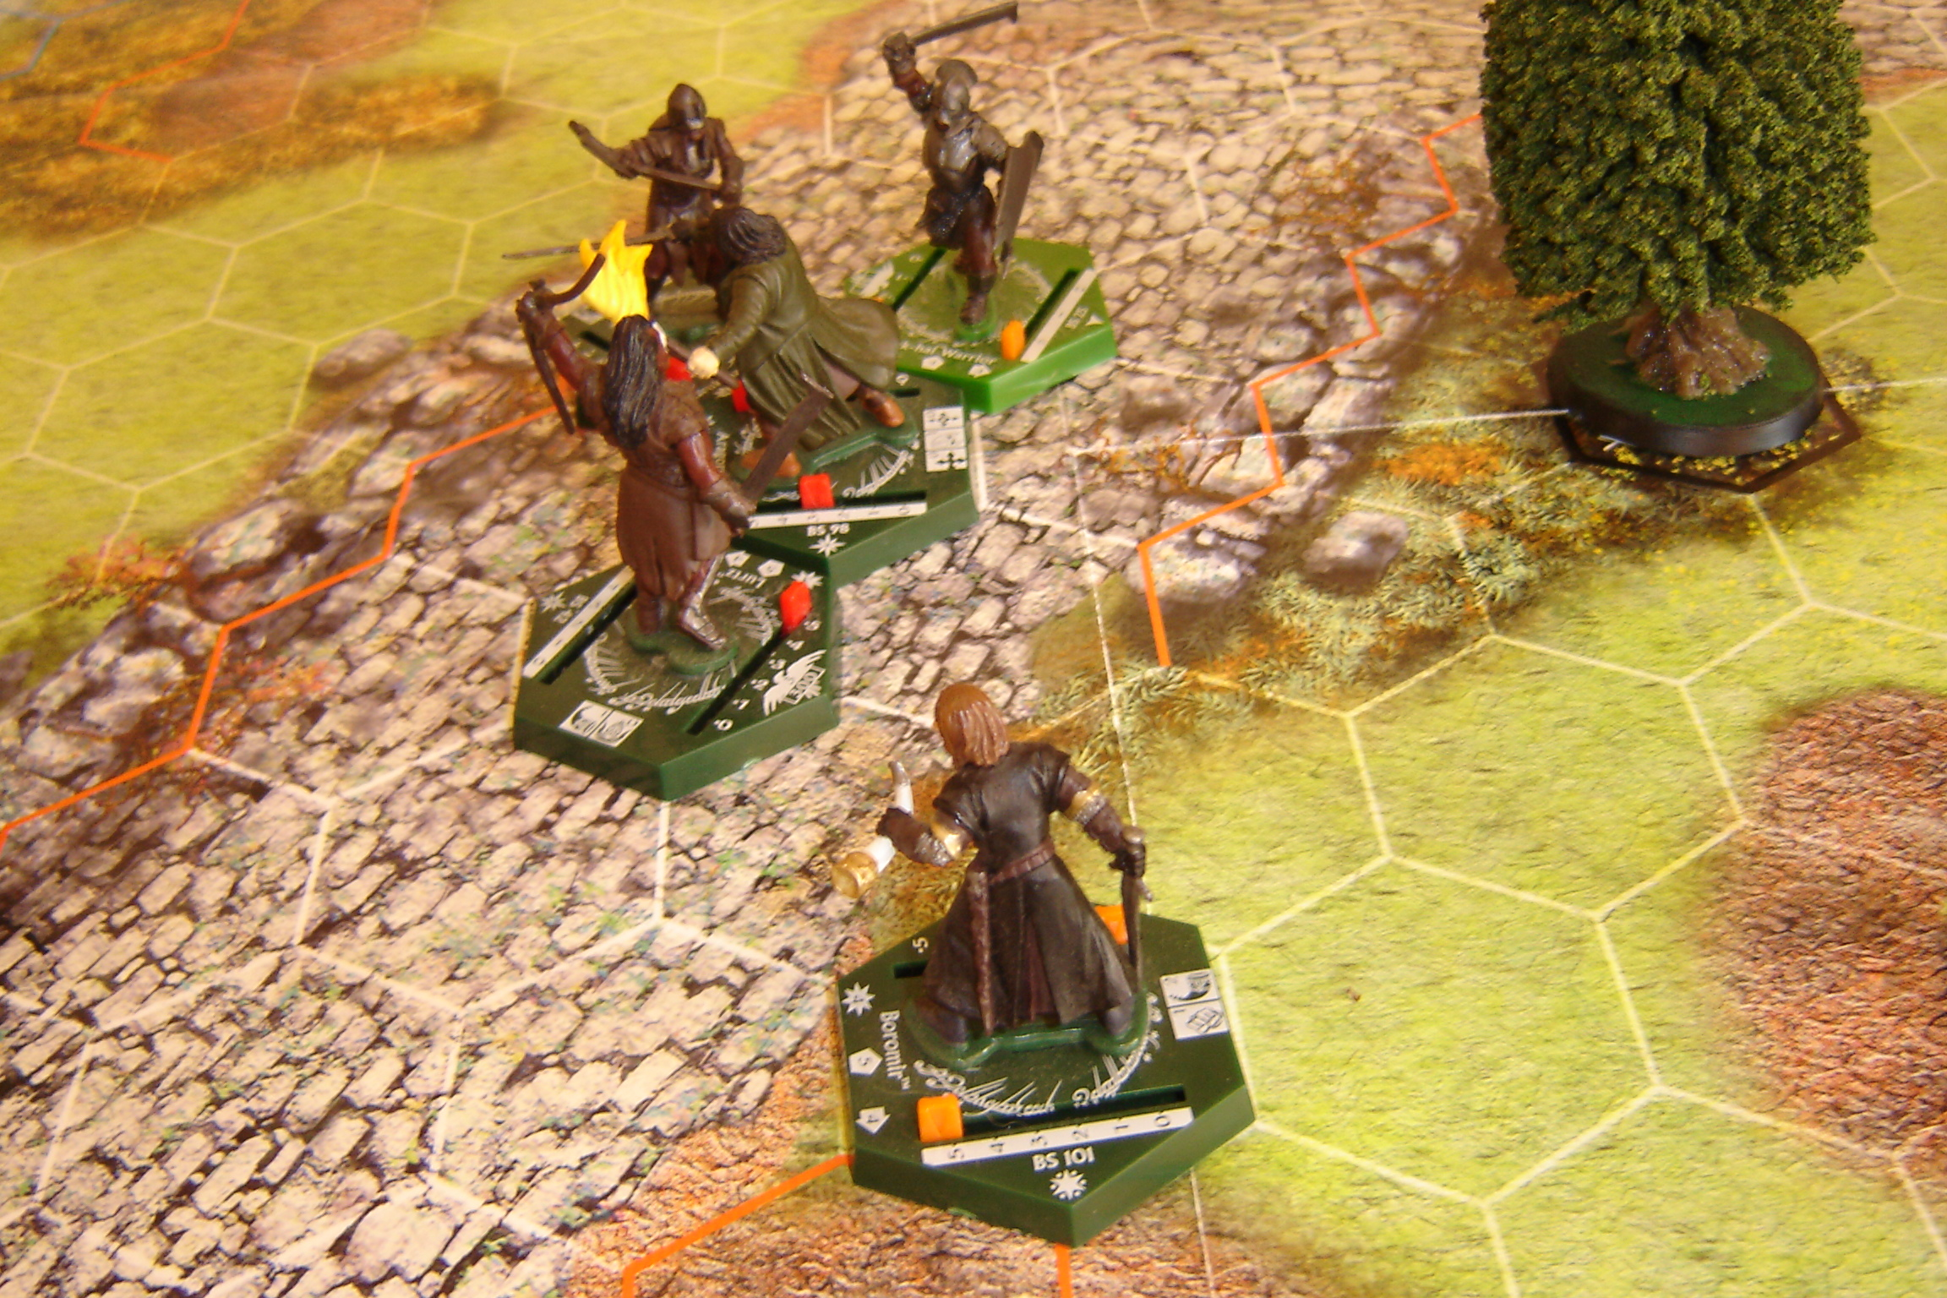
Aragorn is surrounded… Boromir moves in slowly from behind.

Boromir`s Orc attempts to dis-engage from his kill zone, but the trained Gondor soldier easily cuts the creature down. Boromir moves to help Aragorn in combat. “Stay out of danger.” The tall man calls over to Merry not to join him. The Hobbit hangs back, and instead starts searching for Pippin amongst the bodies; his heart is full of dread: “Pippin…. Pippin?” He calls.

The trees are suddenly full of Orcs… reinforcements. Black Uruks of Cirith Ungol. An orange Orc Warrior and a Crossbowman is among them.

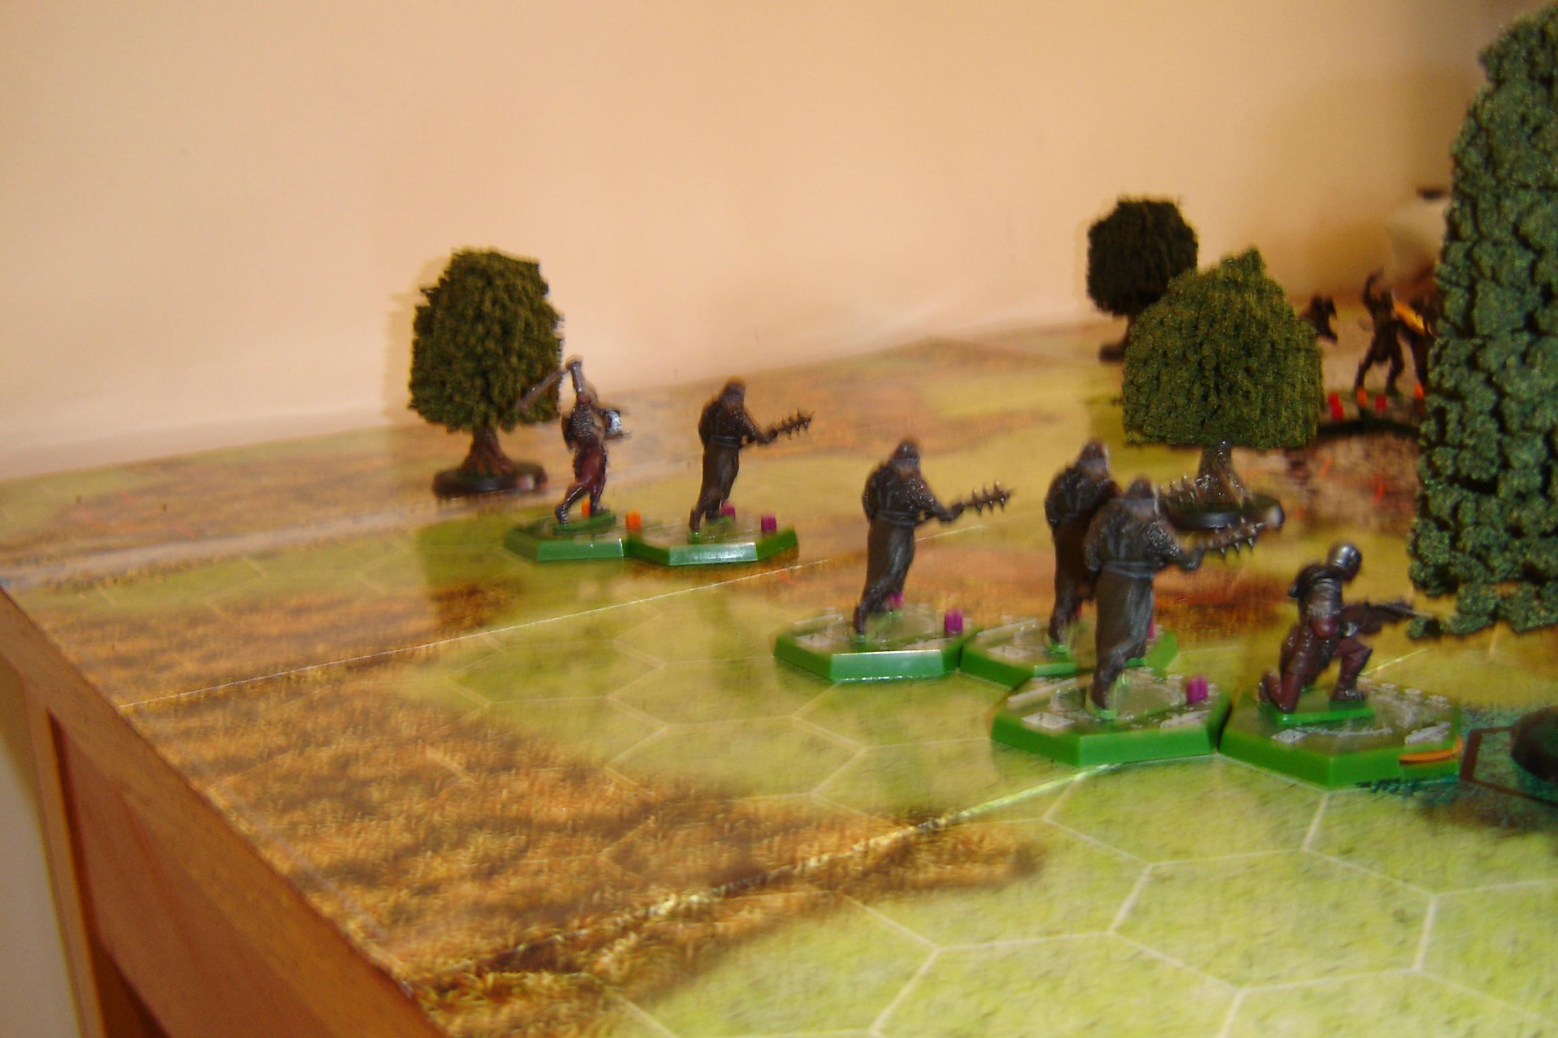
Move 6: Cirith Ungol Reinforcements.

But then! Legolas leaps from the trees behind the Enemy and starts peppering them with arrows. One Cirith Ungol Orc groans loudly and falls dead, an arrow lodged firmly in the back of its neck.

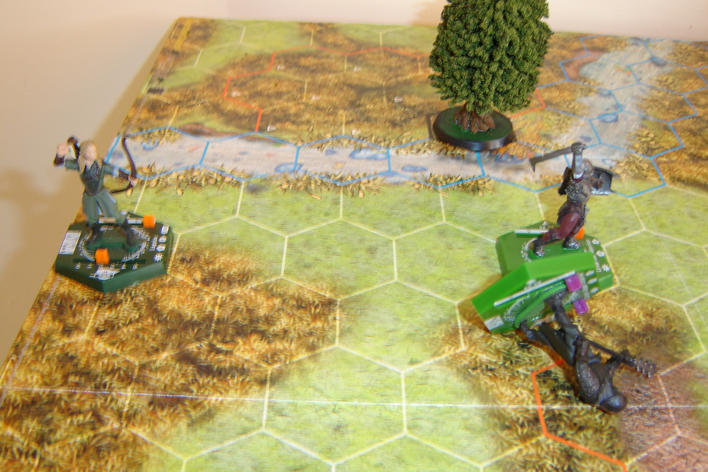
Gimli growls a Dwarvish war cry and charges towards the nearest Orcs. He chops down two Black Uruks +3 dice for attacking from behind, +3 dice for activating Berserker, plus his own 4 attack dice = 10. But the Mordor Orcs are fierce warriors, and using Assassin, they slice three wounds into the Dwarf before they are themselves taken down.

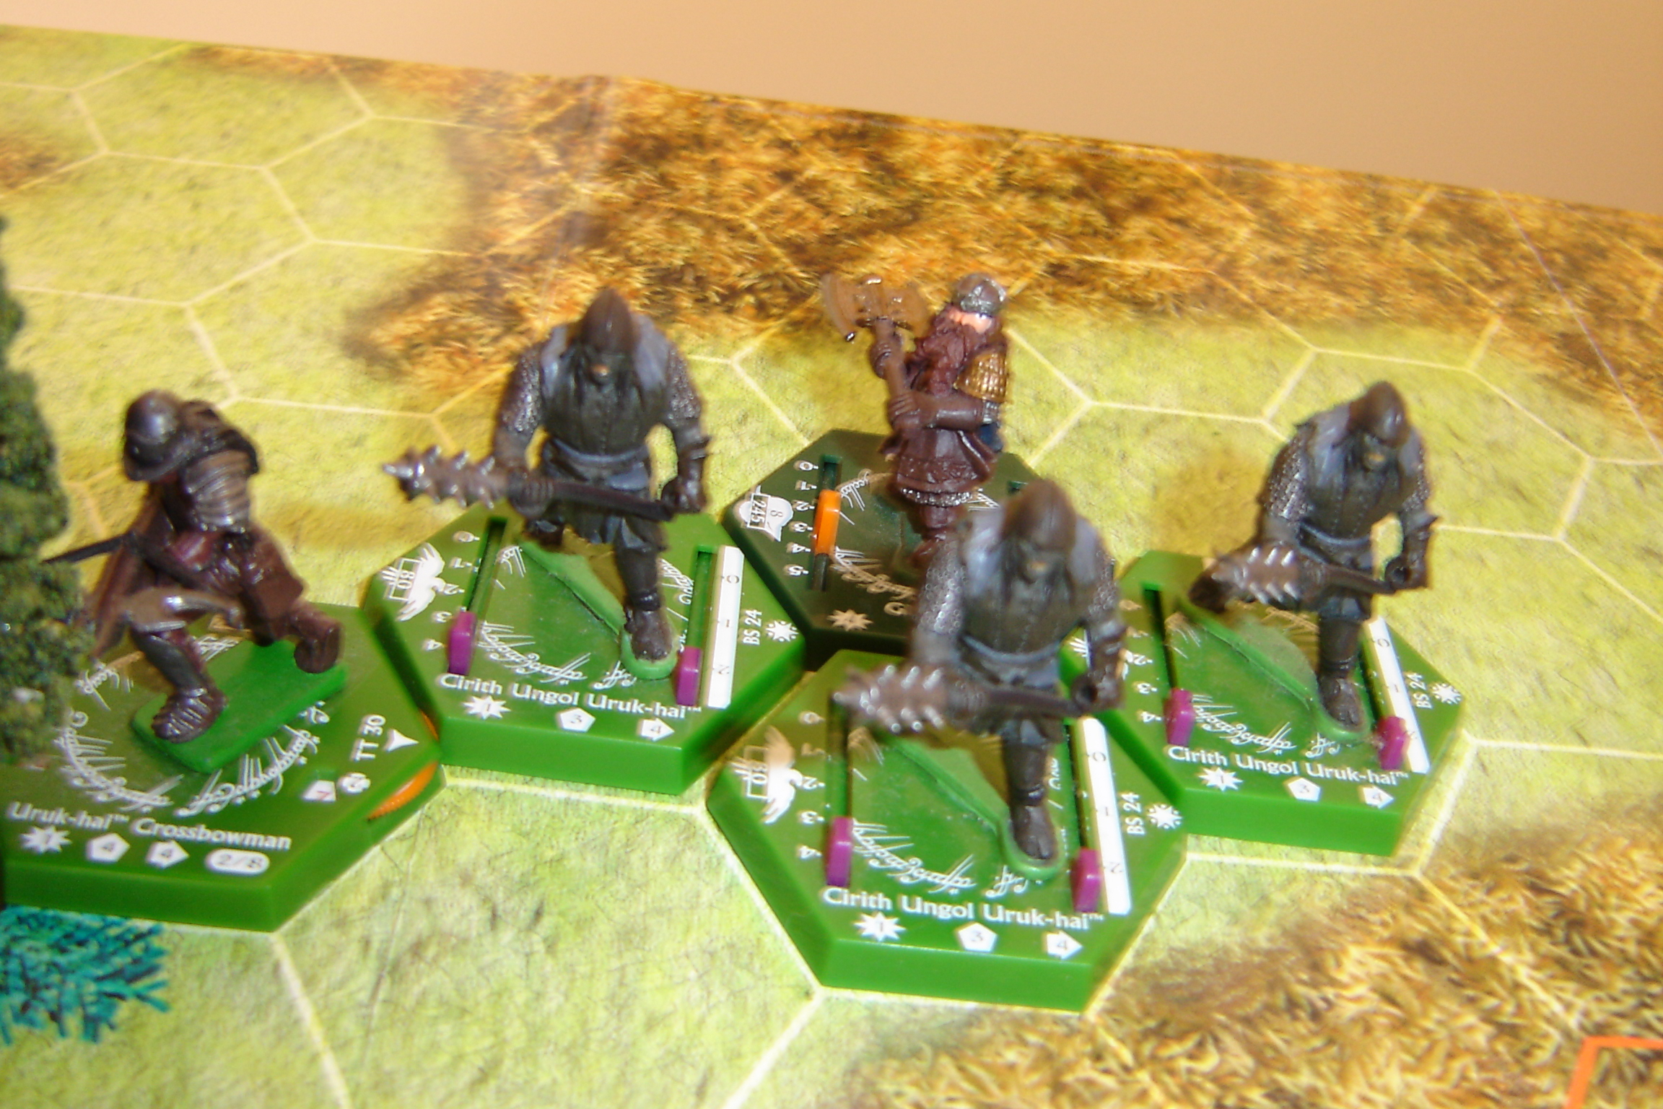
Gimli attacks from the rear.

By the end of the Action Phase on the sixth move, The Orc reinforcements have been somewhat depleted; only three of the new miniatures remain on the map.

Combined attacks from Lurtz, Champion and Minion inflicts 3 damage on the Ranger… enough to kill him. But he activates armour, and reduces the damage total by one die. Aragorn hangs on to life by a single thread. His return strike wounds the minion, and assigns two wounds on Lurtz.

Move 7: Enemy 6 +1 = 7. Fellowship 4. Shooting at extreme range, the newly arrived crossbowman… by a combination of an adjusted glancing blow and critical hit… manages to pierce Boromir`s chest – inflicting a wound on him. The surprised warrior staggers for a moment, before once again regaining composure enough to join Aragorn in the big damage chain in the centre of the map.

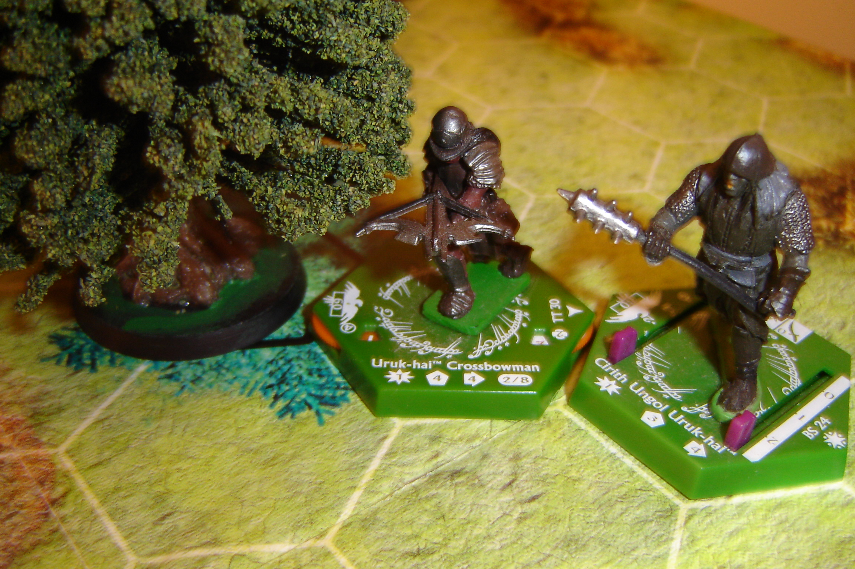
An Orc shoots and wounds Boromir.

Legolas moves forward at great speed…. Seeking new targets for his bow.

Gimli prepares for another round of combat; this time against a lone Cirith Ungol Orc. During the fight he assigns one paint of damage on his foe he fears to use any special ability points because his supply is now so low. The Orc fails to wound the Dwarf at all.

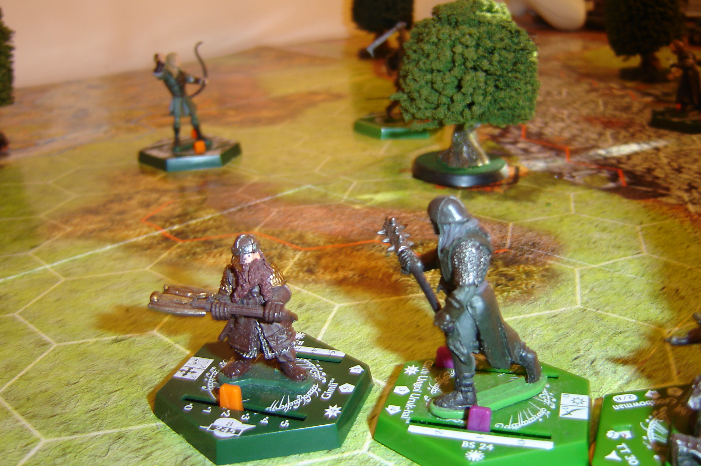
Gimli faces another Orc.
In the main combat, Aragorn (now joined by Boromir) dispatches Lurtz with a clever combo a moves, and slays the Orc minion. But the Ranger is, himself, bought to his knees by the combined onslaught of the enemy – and dies amidst his foes… a warrior’s death.

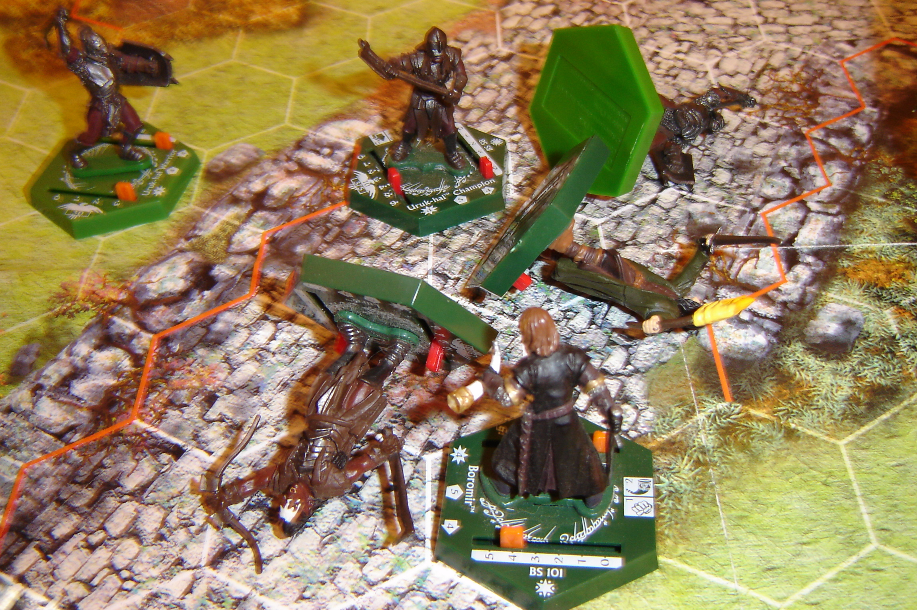

By the end of Move 7, there are 7 dead orange Uruks, 3 Cirith Ungol Uruks, and Lurtz. The Fellowship has lost Aragorn and Pippin.

Move 8: Enemy 4 +1 = 5. Fellowship 6. Legolas uses his last action points to activate arrow flurry and kills the last Uruk Hai orange Warrior.

Boromir and Merry back off fast from the Uruk Champion with all the movement points they can muster. They must keep the enemy away if they can – allowing Legolas to use his bow as long as possible, and giving Gimli the chance to deal with his foe so he can come to their aid.

The Uruk Crossbowman has the taste for Boromir`s blood, and moves within range, hoping for a shot at the Gondor warrior again next move.

But the Orc Champion is having none of it, and runs at Boromir and engages him in combat. Suddenly, Merry is extremely vulnerable – for if the mighty Boromir falls, there will be noone left around to protect him.

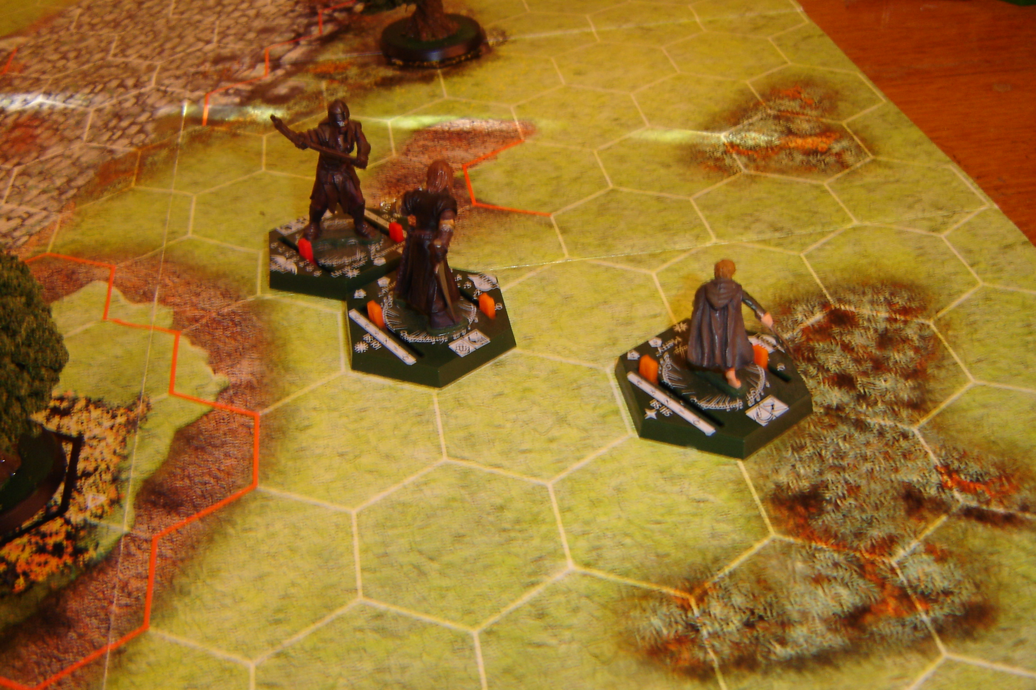
Orc Champion versus Boromir.

The Cirith Ungol creature uses a critical hit and the assassin ability to inflict two wounds on Gimli… enough to kill him outright. But the Dwarf uses armour and saves against one of the damage points. Gimli has no action points left at his disposal for the remainder of this game. But for his sins, he cuts his Orc opponent neatly in two halves.

Boromir receives a wound from the Orc Champion but fails to find a weak spot in his enemy.

Move 8: Enemy 1 +1 = 2. Fellowship 5. Gimli and Legolas both fly like the wind to help Boromir. At best, they are one or two moves away.

Merry backs away even further, to the edge of the map… just in case the Champion decides to try and dis-engage from Boromir and come at the Hobbit by surprise.

The Orc Crossbowman nonchalantly turns, looks the charging Dwarf in the eye… smiles evilly… and shoots Gimli straight through the heart! Without action points to activate armour to defend against the attack – the Dwarf is struck dead.

Oh my God! What a sudden and unhappy blow for the Fellowship; and Legolas who is a mere hex away can do nothing but watch in horror as the foul Orc takes the life of his dear friend.
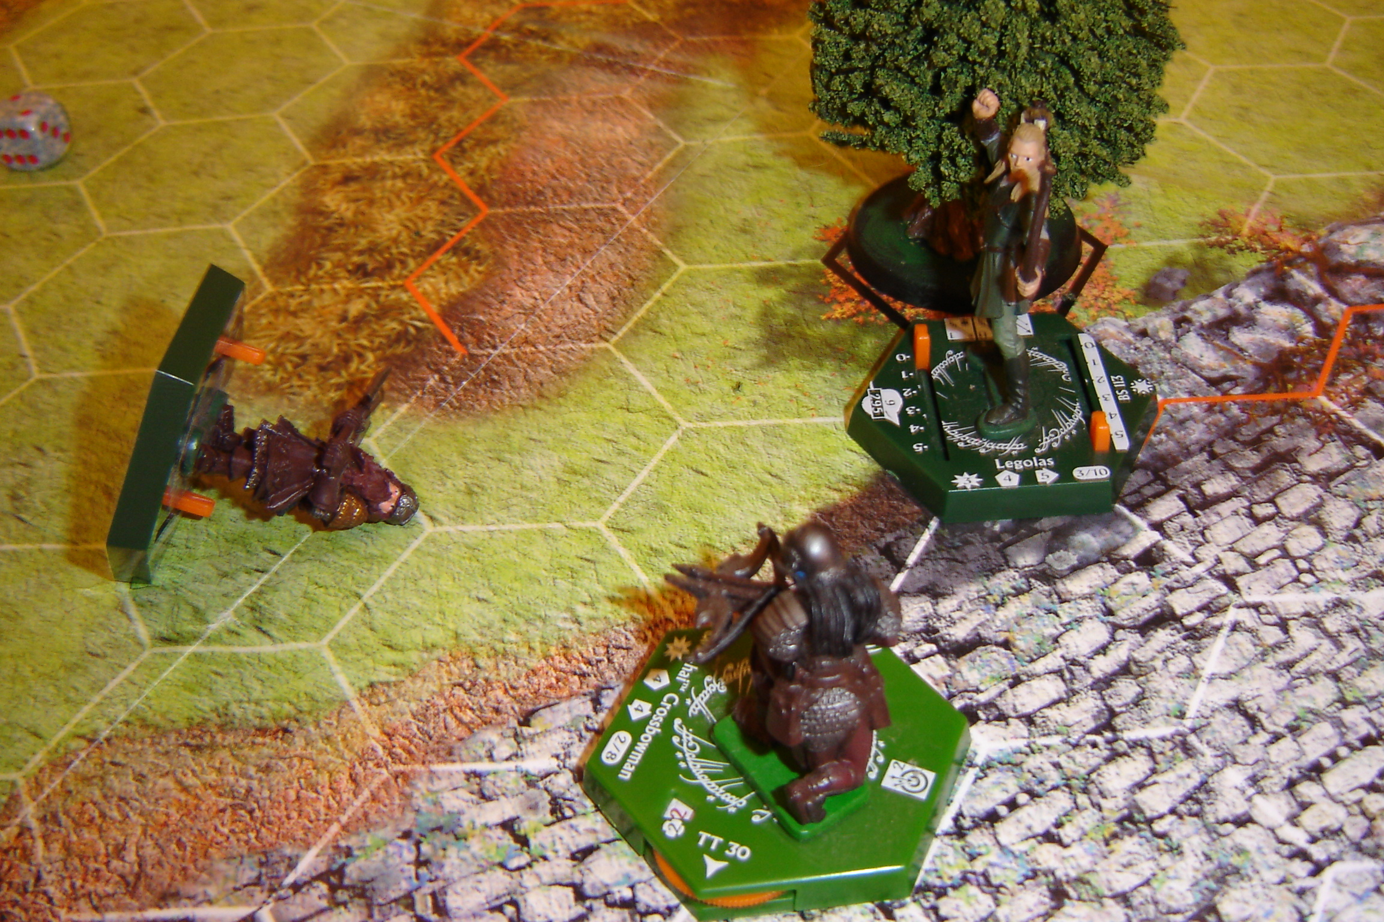
Gimli is killed by an Orc Crossbowman’s bolt.

Meanwhile, the Orc Champion reduced Boromir`s life by yet another point. Boromir can`t seem to touch this dreadful foe.

Move 9: Enemy 4 +1 = 5. Fellowship 3. The Orc Crossbowman bravely advances and engages Legolas, no doubt hoping to slow the Elf down and prevent him from reaching his companion in time to stop the Champion from killing the Gondor soldier. Legolas dis-engages moving through the Orc`s kill zone twice… receives a wound, but keeps going, and joins his companion against the Uruk Hai Champion.

Hmmmmm. This will be close.

Oh my goodness. Unbelievable! Combined dice from Legolas and Boromir only manages to score a single hit – followed by a single wound, which the Orc Champion avoids easily by using armour. None of the combatants have any remaining action points at this stage, I should add; but this doesn`t stop the Orc from assigning yet another wound on Boromir. The Gondor Warrior is now a mere point from death.

Move 10: Enemy 5 +1 = 6. Fellowship 4. The Orc Crossbowman joins the fight, and now the balance is definitely in the favour of the Enemy. Only the end of the game at the end of the 12th move looks like it can save the Fellowship now, but that might be just too far away to save them from the inevitability of that bloody Orc Champion’s fearful axe.
At the end of Move 10, Boromir lies dead on the ground. The only damage inflicted on the enemy is a single wound placed on the Orc minion.

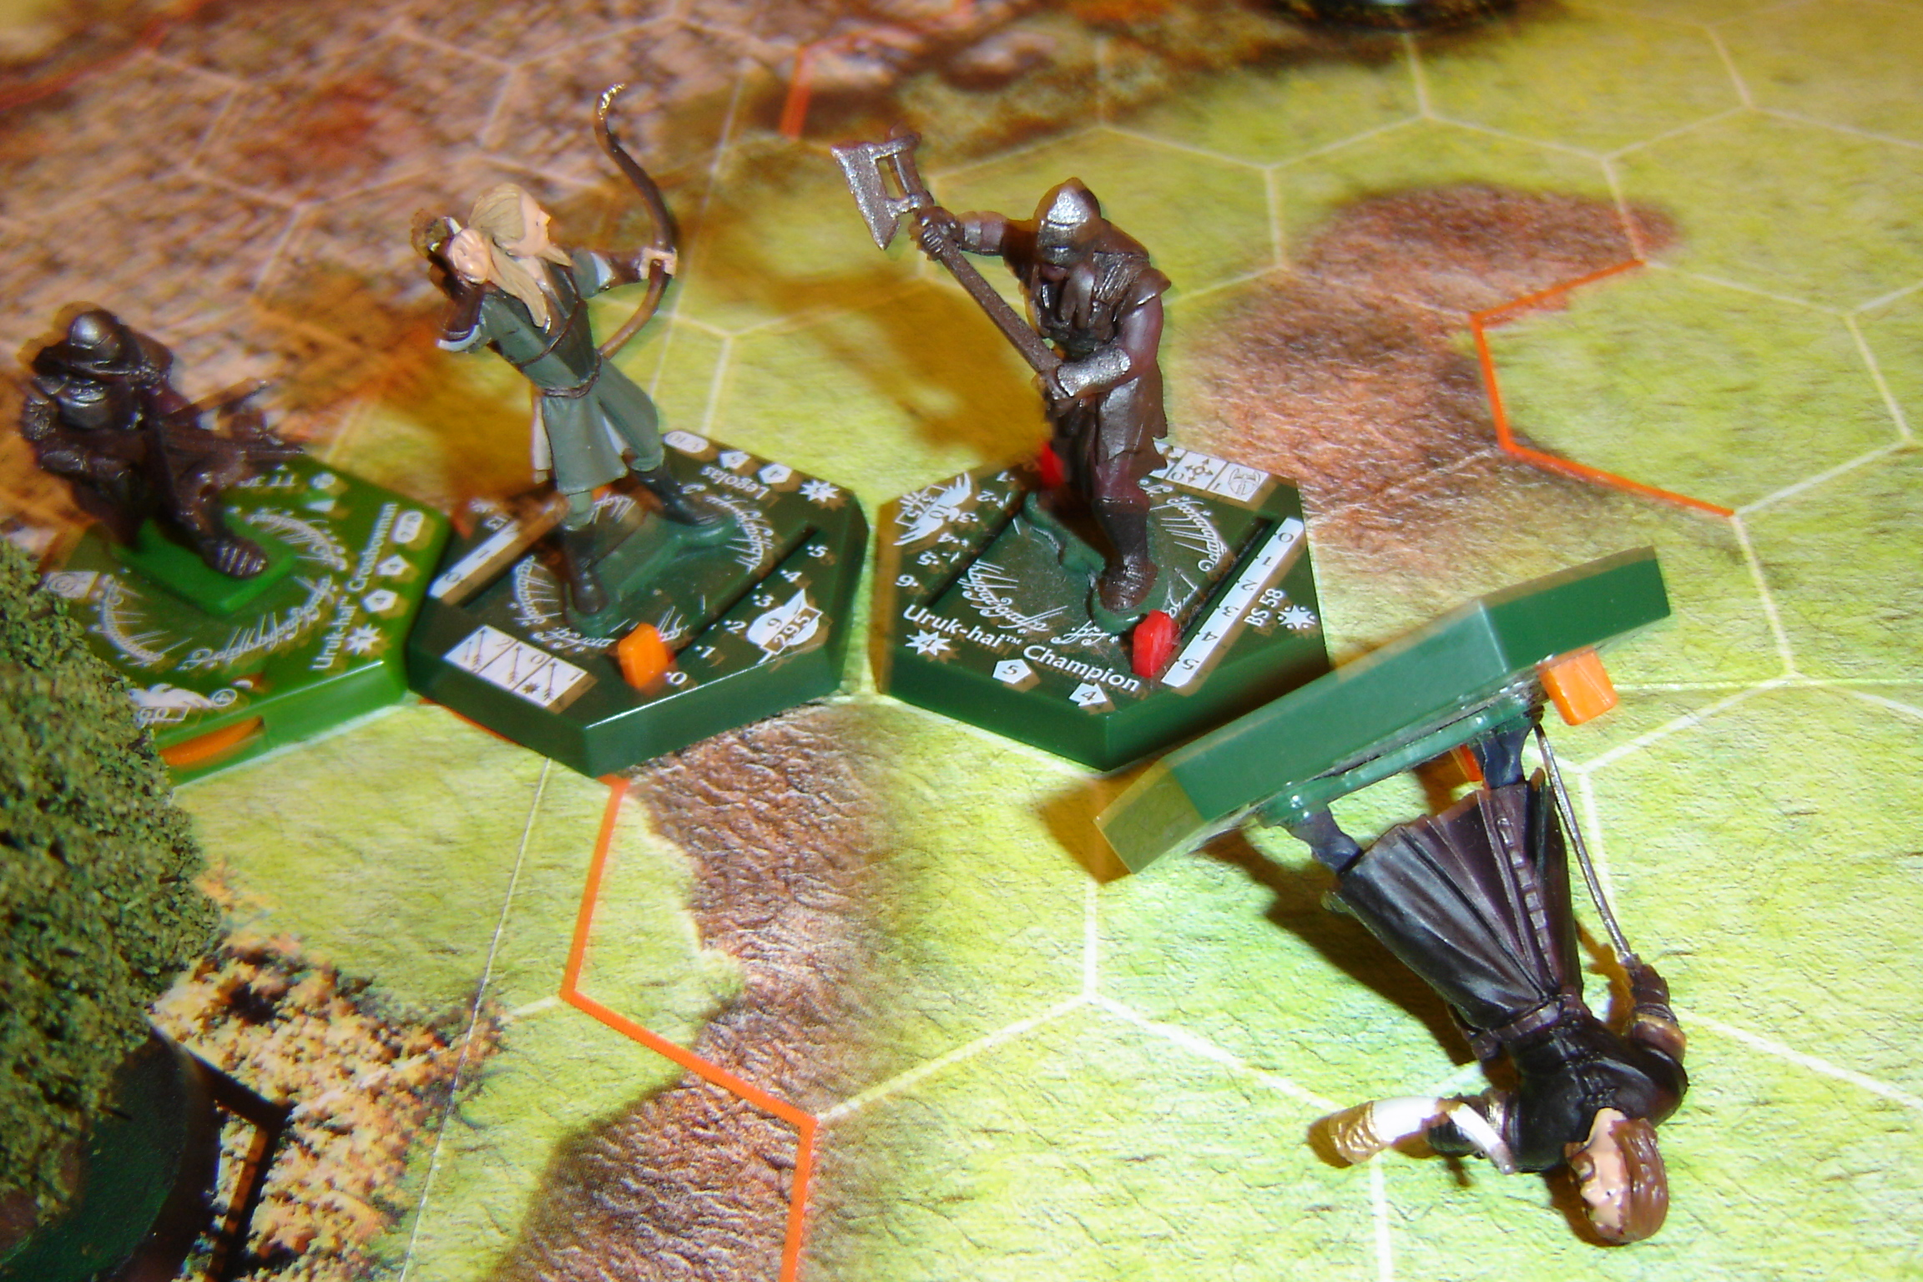
Boromir dies at the hands of his enemies.

Suddenly, there is nothing much stopping the enemy from engaging Merry.

Move 11: Enemy 6 +1 = 7. Fellowship 2. The Orc Champion dis-engages form Legolas… receives a wound for his pains… and moves to engage the Hobbit. His movement leaves him a single hex short of reaching his target.

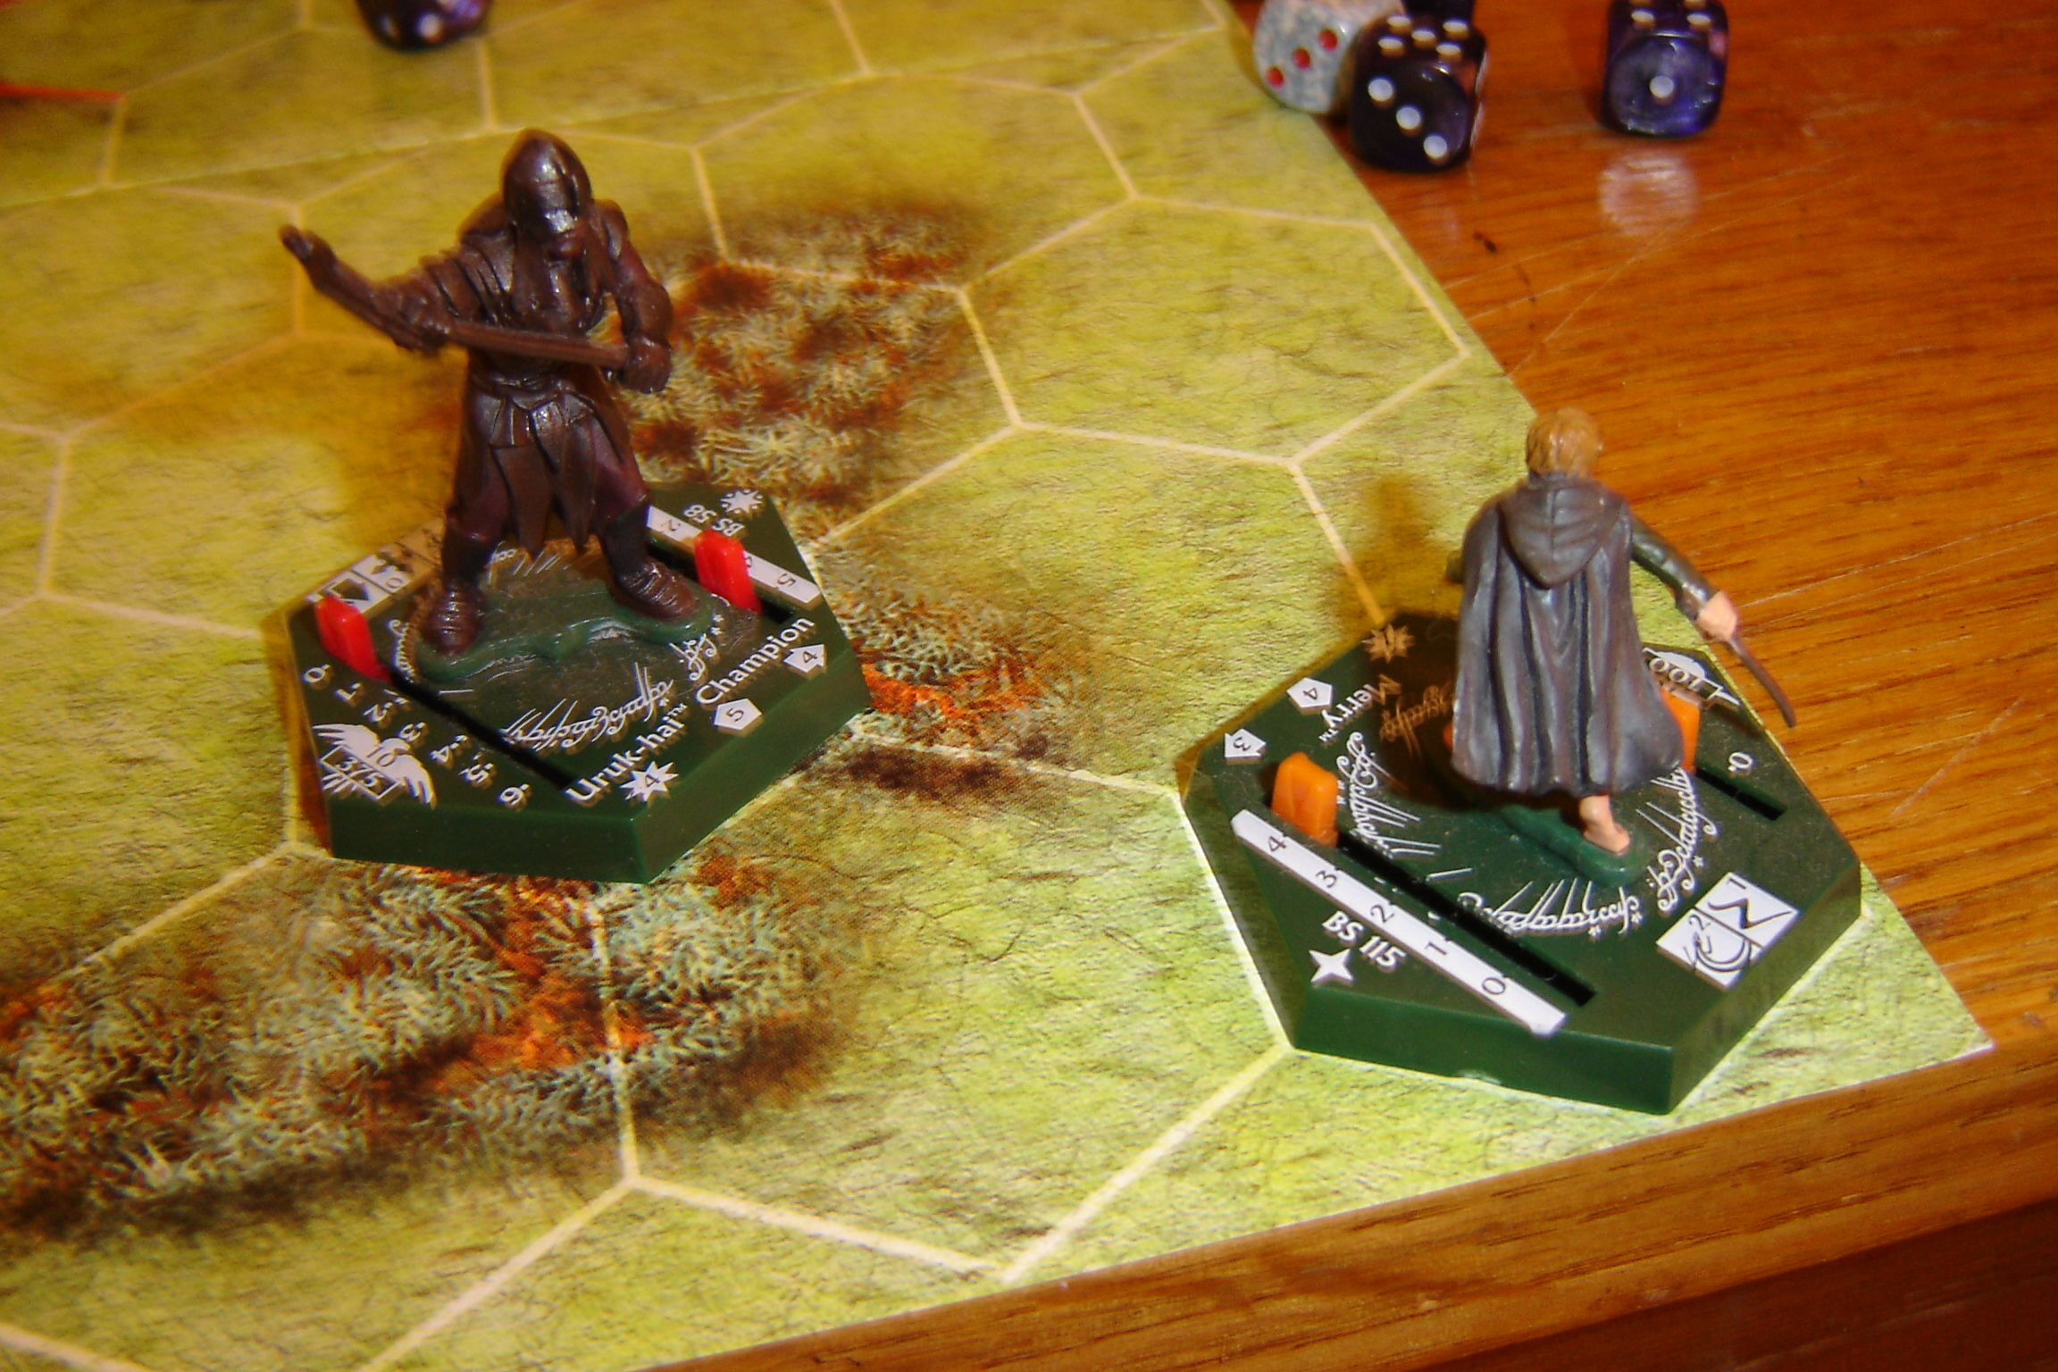

With ease, Legolas disdainfully dispatches the Orc Crossbowman.

Move 12: Enemy 4 +1 =5. Fellowship 2. The Champion rushes Merry. Legolas runs up behind and joins the fight.

Final Combat Phase.

The Champion throws well – and ends up assigning two wounds on Merry. The Orc takes a wound on the chin… and suddenly the game is over.

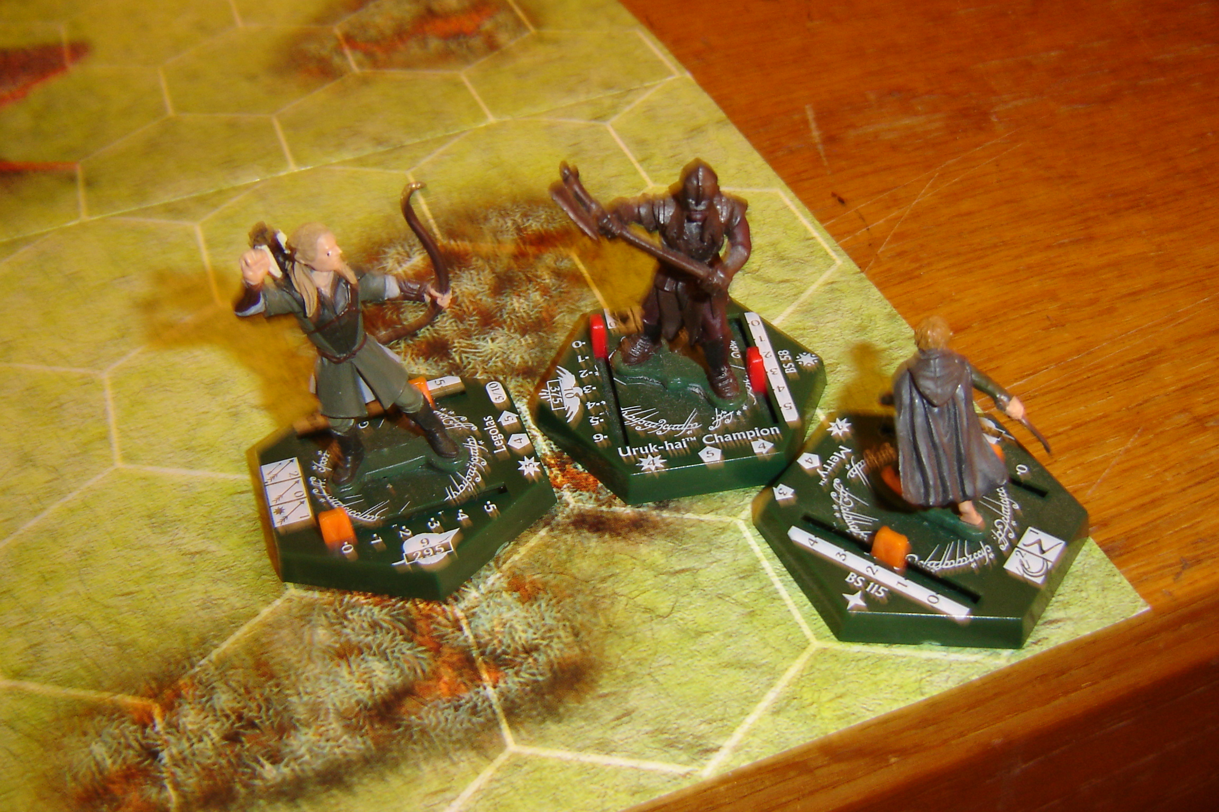
Final move.

Oh my God! In the end, only three miniatures remained alive throughout the whole map. That was amazing. What I`m personally impressed with is how close the game was and how undecided the outcome – even to the end. Not bad really, considering I threw this scenario together in five minutes flat. I literally made it up on the spot which miniatures to use, and which moves they would appear as reinforcements. Obviously the main characters of this scenario were dictated by what is written in the book and film… but even so, I think I deserve a good pat on the back for this one (blowing ones own trumpet is never a pretty sight – memo to self LOL)

I guess Merry would stumble over the prone figure of Pippin, lying groaning and sore under a dead Orc or something. With Legolas` care, the Hobbit would no doubt make a speedy recovery, and would be fit to travel again in a few hours. Perhaps Pippin had been dragged off some distance (away from the map), and Legolas would have had to go searching quite some time before he found him rolled up in a foul smelling sack under the branches of some old and gnarled tree.

But oh! woeful day. Imagine waking up to find most your companions had been slaughtered? Aragorn is gone! The noble Boromir is slain! The mischievous though innocent and happy-go-lucky Pippin! Even the stout hearted Gimli – all gone, all killed trying to defend the Hobbits. Quite a sobering thought, isn`t it! Just Legolas, Merry and Pippin left of the original Fellowship. Without Aragorn’s leadership, I wonder what the remaining companions would have done… gone after Frodo? Would the Hobbits have returned to the Shire? Would Legolas grieving for his friend have built a funeral pyre in honour of the Dwarf, then returned with a heavy heart to his father in the Woodland Realm? It seems doubtful they would have carried on as a Fellowship… quite honestly, without Aragorn and Boromir`s influence, there would have been nothing much else for them to have done. A part of me thinks it is quite possible Legolas would have sent the Hobbits home alone, then tried to have followed Frodo and Sam; offering his services and protection for as long as it was needed?

But that’s all just speculation. The battle was a sound win for the Fellowship; but the victory came at quite a price!

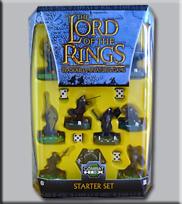
TMG LotR Starter Set (blissful nostalgia).

I did make one rather large booboo though, I`m afraid. Because it`s been quite some time since I played a TMG battle, I completely missed the fact that the red based Boromir miniature has the special ability aggressive strategy. I mistook the symbol for courage and denied him quite a considerable fighting advantage in combat. Oooops.

Ahh well, such is war.

