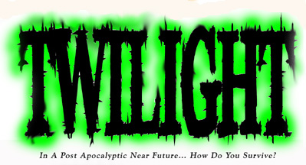
Twilight World ~ The Game
15mm Miniature Wargaming in a Post Apocalypse World
Introduction
Until now, they have only existed in our imaginations. "When there's no more room in Hell, the dead will walk the earth." Now humanity must fight for its fragile existence, and the right to survive in a Land filled with the un-living.
Description
Twilight World is a basic game system that was designed for quick and easy miniature wargaming in a modern horror setting. These rules allow players to fight desperate battles in a number of different ways: either with small groups of human survivors (heroes) in low intensity battles, primarily against other players who control zombie hordes, or roving gangs of villains... and worse; or you can play co-operatively (with all players working together) against an A.I. built into the rules system itself. Or you can even play solo (one person playing a single hero or a group of heroes... working against the built in rules A.I.).
These rules are designed to play on a table top using 15mm miniatures (but 28mm would work just fine too). Movement and firing distances are made using a squared game board, although there is no reason why you can't play on a hex board, or simply measure distances in one inch (or centimetre if you prefer) increments as you go. However, by default these rules assume you will be using some sort of squared game board. The rules also require the use of up to four 6-sided dice.
A battlefield usually consists of some 3D terrain pieces. These represent obstacles such as walls, buildings, deserted vehicles, raised roads, rivers, bridges, trees, etc, etc. All this can all be made from scratch with relative ease by even the most frugal modeller... or are commercially available from many shops and on line resources.
Assigning Roles
Prior to play, the Player(s) must select a group of stock characters to play with. One player should be selected to play the zombies; another player may even field a gang of villains pitted against both the heroes and the zombies.
Turn Initiative
The player(s) each rolls two dice every turn to decide who goes first. The player(s) with the highest score goes first and the player(s) who lost the roll goes second. In a three sided game, the zombies always go last.
Activation Points
A few main Characters, and Villains have Traits which allow the generation of 1D6 worth of Activation Points (APs) per side for each turn. APs are used to command lesser troops such as Friendly Minion Forces and Villain Henchmen. Without these APs lesser figures cannot act. No more than 1 action may be applied to a figure during a turn. Tokens should be used to keep track of which figures have moved each turn by placing an AP token next to each activated figure.
Note: Characters do not require APs to act. Zombies receive 4D6 worth of APs each turn, despite having no leaders. This means that however many zombie miniatures may actually be in play, only a limited and random number of them can act on any given turn. This represents the slow witted and unpredictable nature of the deathless hordes.
Standard Actions
Players normally get to do 1 thing each turn with each of their activated figures: move, shoot, or make a close combat attack (a character possessing the Special Attack trait is an exception to this rule...and can move, attack, then move again).
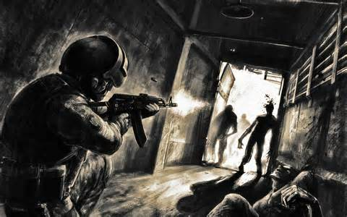
Movement
Standard Human Movement is 6 squares. Zombies usually move 4 squares per turn. Obstacles capable of being crossed and difficult terrain reduces movement by half: i.e. each square will cost 2 movement increments to enter. A figure may move through any friendly figure as long as it does not end it's movement in a square occupied by another figure. A figure may not move through an enemy figure's base (the Sneaky trait is an exception to this rule).
Combat
Targeting Figures
A figure may attack any other figure that is not completely obscured from sight. Figures may only attack targets within Line of Sight, but figures have 360 degrees LOS around their base. Any terrain, objects, or other figures which partially obscure the target (not including the target's square) raises the difficulty of the attack by 1. This modifier is applied cumulatively. If this takes the attack outside the normal possibility of a hit, a successful critical hit is the only other option available to the attacker. Each individual attack or weapon type has a To Hit number which is required to cause a wound.
Human Unarmed Combat
Humans cannot make effective attacks against zombies without the use of weapons. A figure attempting to wound a zombie with his/her bare hands requires a 6 to make a successful hit, and can make two such attacks.
Special Attack
A Special Attack is a trait which allows a figure to move/attack/then move again. To make a special attack the attacker must not start the turn adjacent to an enemy figure. Special attack is made by moving (at least one square) and making a full attack. If the enemy figure is removed as a casualty, the character may continue moving up to his/her full remaining movement allowance. Special Attack may be made against a target that is adjacent or otherwise.
Some characters may make double Special Attack. Which means potentially they can move... make an attack... continue moving... then engage another enemy... special attack and (assuming movement points remain) still continue moving.
Range Attacks Made Through Friendly Figures
If a friendly figure partially obscures line of sight on a ranged attack, an attack roll can still be made with the difficulty modifier of 1 added. If a ranged attack is made and misses the intended target, a separate roll must be made for each individual attack to determine if any friendly's were hit. The same attacker modifier of 1 is added for these rolls.
If multiple friendly figures obscure the intended target, begin this process by selecting the friendly figure closest to the shooter, radiating out. If multiple friendly figures obscure the intended target and one friendly is hit by an attack, further rolls must still be made on that particular friendly target.
Attack Roll Results
Double 1's and Weapon Failure
Whenever double 1's are rolled by any weapon attack (i.e. when an attacker decides to throw more than one attack die), this indicates a weapon failure and the end of the character's available attacks. If the weapon being used is a firearm, this indicates that all ammo for that particular weapon is depleted. The weapon may be used as a club (if possible) or kept for reloading with Spare Ammo Markers. Double 1`s rolled in melee simple indicate a miss.
Double 6's and Critical Hits
Critical hits indicate a devastating hit to the target. Any target hit by double 6's receives an additional wound. Thus it is possible for an attacker who ordinarily has no chance of achieving a hit to score double 6's and get a free critical hit. Call it a lucky attack.
Receiving a Hit, Saving Throws, and Dying
Receiving a Hit
Whenever a figure receives a successful hit (including critical) from an opposing or friendly figure, that figure is allowed any Saving Throws from armour or traits they might have. If a Saving Throw is successful, all hits from that attack are ignored. If no saving throws are available or the saving throw fails, the figure receives the wound(s).
Saving Throws
Various abilities as well as armour and motor vehicles allow figures to receive Saving Throws. Saving Throws allow a figure who has received a potential hit to ignore the damage. Saving Throws are represented by numbers from 1-6 (such as 4+, 5+, or 6). A figure must roll that number or greater on a 1d6 to make a successful saving throw.
Wounds, Unconsciousness and Death
Whenever a Character is successfully hit, it receives a wound (2 if it is a critical hit). This wound is tracked using wound tokens. The number of wounds a figure may take depends on the number of wounds indicated on the Stat Cards (found at the back of these rules). When the wound tokens placed underneath a figure's base reaches the Stat Card limit, the Character is considered unconscious and cannot act. Any further melee attacks made on an unconscious character are classed as automatic hits, and ranged attacks with a +2 bonus (a natural 1 thrown is always a fail). Any further wounds made on an unconscious character, result in the death of the Character and their removal from the game.
Note: Wounds are not tracked on Villains, Henchmen, Zombies, or Friendly Minions and result in immediate death upon receiving a hit... bitten, infected, and turned bad; this former heroine has now become a zombie. Only Characters can have more than one wound.
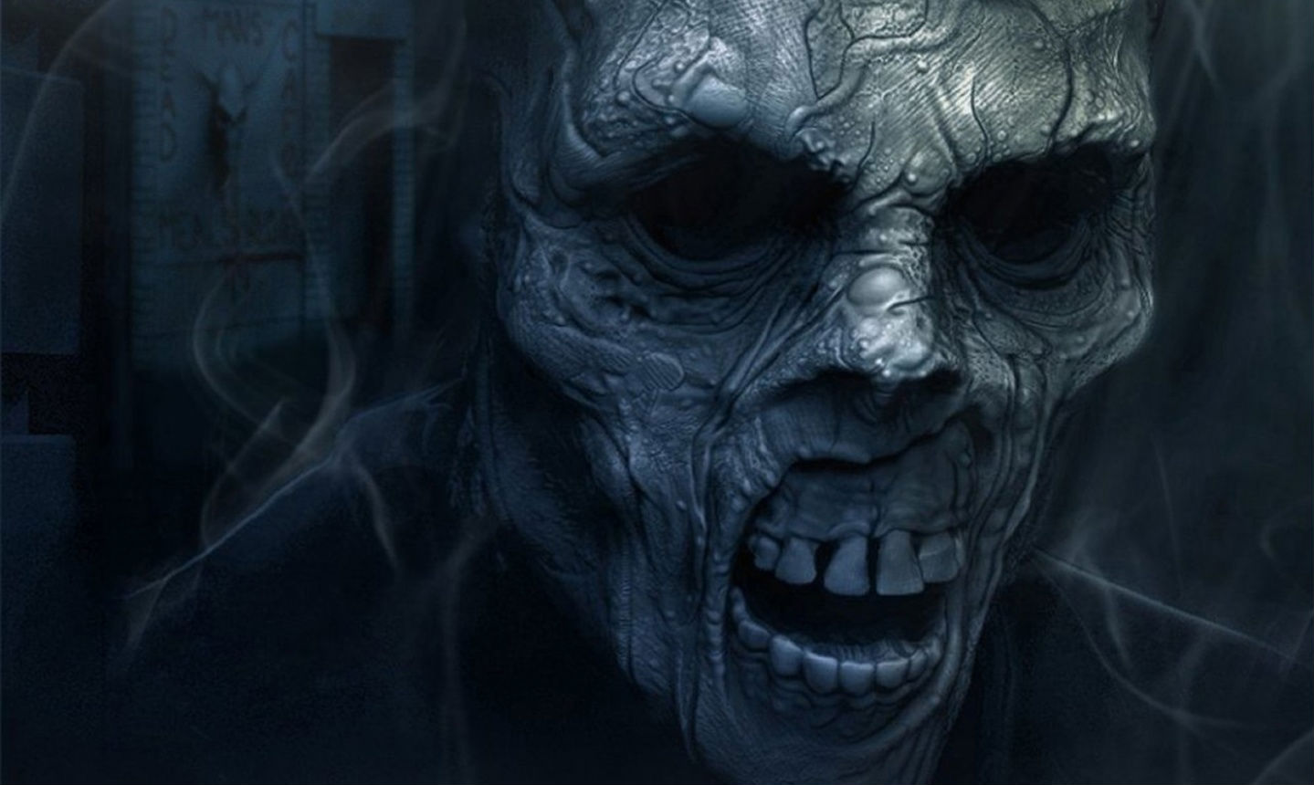
Spawning New Figures
The zombie player will usually be able to spawn or summon new figures during a game. When this occurs, the new figure must be placed out of view from any opposing figures and with no enemy figures within their own Line of Sight. If this cannot be done, the Player must add the new figure to any location on the outer edge of the battlefield (randomly determine which edge) but not adjacent to an opposing figure.
Using Explosives
These weapons do not require line of sight to a target figure but must have line of sight on the intended target square.
Making the Attack
When using explosives a normal to hit roll is made. If the target number succeeds, the explosive lands and detonates where the character wants and injures everything in that and all adjacent squares. If the target number fails, an additional roll of 1d6+1 is made to determine how many squares from the target the explosive travels and 2d6 is then rolled to determine the direction. The "T" in the figure below represents the Target for the explosive. 2, 3 always represents the direction the explosive is being fired at.

Blast Deviation Results (2D6)
12 | 2,3 | 4
11 | T | 5
10 | 7-9 | 6

Explosive Blast and Cover
Throw all the dice for the explosives for each figure caught exposed without cover within the surrounding blast area: but they can take only 1 wound (regardless how many attack dice are actually thrown). A figure within the blast area does not receive damage if an object, barrier, vehicle, or building separates them from the blast. Other figures do not provide cover against blast effects. Any figure in the target square rolls as many dice for damage as the weapon allows and must take a hit from each successful damage roll. A Saving throw is allowed (i.e. one successful save will delete all and any damage in that square).
Double 6's with Explosives
As with other attacks, if double 6's are rolled during the attack roll only, the explosion does an additional wound to all figures in the blast radius.
Tripple 1's with Explosives
Tripple 1's during an explosive attack roll, results in the explosion detonating directly on the figure that made the attack with the blast radiating out from their location.
Figure Types
Characters
These are the mainstay for your games... the heroes. These are the good guys who flesh out your games.
Friendly Minions
These figures are non-character support guys. They do not have the natural resolve to fight the zombies and roving villains on their own and must be lead and persuaded. These forces include but are not limited to Military Grunts, Bio-Hazard Teams, and Civilian Mobs. These Friendly Forces are often assigned to a single main character able to generate APs. If this character is slain, the Friendly Forces are considered to have fled and are removed from play. Exceptions to this rule do occasionally apply, depending on the scenario being played, of course.
Villains
These are the individual bad guys and major antagonists. If these are Henchmen/Sidekicks (followers) they will require APs to take any actions during a turn. Villain types also includes all major Cult and Gang Leaders, and so on.
Minions
These include all manner or minor bad guys: such as cultists, and critters who only serve as tools of evil. These Minions are often assigned to a specific Villain who generates APs for them. If this Villain is slain, the Minions slink away and are immediately removed from play.
Assigning Equipment & Abilities to Figures
An addictive part of miniature wargaming comes from detailing and outfitting your characters. After selecting a group of figures you wish to play with, decide appropriate characteristics to assign to the figures based on their equipment and assumed abilities. After detailing this information, create quick stat cards with all pertinent information added for quick and easy reference of all characters, villains and minions.
Spare Ammo Markers
Each Main Character possessing a ranged weapon (or chainsaw) or each group of Friendly Minions starts the game with 1 Spare Ammo Marker, in the form of a token. This token may be discarded as a free action to reload any weapon that is Out of Ammo as a result of rolling Double 1's. This token may be used on any ranged weapon or given to another adjacent miniature.
Note: Minions only receive 1 Spare Ammo marker for the entire group (but can find more).
Giving Items to Other Characters
Stock Equipment which is assigned to characters and printed on their cards may not be traded or given to another figure. Only Spare Ammo Markers and Goal related items may be passed on or picked up during play. At the start of any character's turn, that character may give Spare Ammo to another adjacent character as a free action.
Equipment on Dead Characters
Any personal equipment belonging to a character that is killed is lost and cannot be recovered (unless you decide otherwise). Spare Ammo and Goal related items recovered from the board are placed back on the board if a character carrying them is slain.
Picking Up Goal Related Items
Goal related items can be placed on the battlefield as objectives or game goals. These may be picked up (as a free action) during a move action simply by moving over them.
Traits and Unnatural Abilities
Traits
- Ambidextrous: May make two separate groups of attacks using two light weapons.
- Brawler: May make 3 unarmed hand attacks per round at a 5 to hit.
- Can't Drive: Cannot operate a vehicle.
- Car Thief: May start vehicle without key in 3 turns.
- Fast Runner: Move 10 squares per turn.
- Hide: May hide assuming there is cover to hide in or behind from every zombie of villain on the board {e.g. behind a dustbin or trash can, behind a wall or a tree, inside a trash can, inside a car, lying flat on the ground during bad visibility, etc}, but cannot perform any other action whilst hiding. While hidden, a figure can't be fired upon or attacked without opponent making a Spot Hidden roll (5+).
- Limited Mobility: reduced movement.
- Leader: 1D6 APs (randomly determined each turn), and +1 to the initiative roll each turn. To save time during play, combine actions points of all same side Leaders at the start of each turn.
- Lucky: May call for any player (including self) to re-roll any dice roll, once per game.
- Medic: Can treat unconscious characters by giving up actions for three consecutive turns to recover 1 wound on an injured person or self. May only use once per figure.
- Poor Eyesight: Has a maximum combat range of 10 squares using ranged weapons.
- Advance Spot hidden: 3+ to spot hidden (1D6). +1 on each turn's initiative roll.
- Small Build: Low wound capacity (2 total): e.g. most old men/women, invalids, and kids.
- Tough as Nails: May take additional wounds (4 total).
- Inhuman: Receives 5+ saving throw against wounds.
- The Blight: Characters killed by this figure's attack return to life at the start of the following turn as a zombie. This new zombie is controlled by the zombie player.
- Scout: This figure is not placed normally. During the course of the game at the start of any turn (if a 5, or 6 is rolled - roll once each turn if initial roll fails), the player controlling this figure may place the figure anywhere on the playing area (but no closer than 10 squares from an enemy) and give it an action that turn.
- Jump: This figure has the ability to leap or jump extraordinary heights over walls and other obstacles: i.e. ignore all blocking terrain as long as their movement ends on normal ground.
- Monster: Receives 3+ saving throw against all wounds.
- Night Vision: This figure may ignore the range reducing effects of Darkness. Note: Night time normally reduces all shooting LOS to 10 squares.
- Regeneration: Must remain motionless for 1 turn to re-gain 1 wound.
- Special Attack: Provided the model is not in an enemy‘s kill zone at the start of the turn, this model may interrupt its move at any time to make up to 2 attacks versus an enemy model - provided the figure has enough attacks available to make multiple attacks, and then continue moving (provided all enemy is removed as a result of the free combat).
- Sneaky: This character may move through enemy figures without hindrance; yet may not end its move actually in an enemy square.
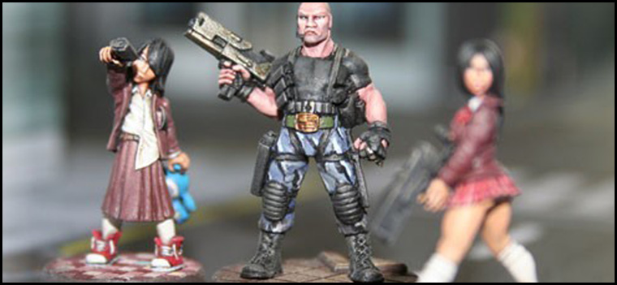
Weapon & Equipment Descriptions
Ranged Weapons
These weapons include all variety of firearms and projectile weapons that can be used to make attacks at a distance, so long as line of sight and range requirements are met. Some double up as melee weapons and can be used as clubs.
Weapon | #of Atts | Range | To Hit | Wgt | Special
Hold Out Pistol | 2 | 8 | 6 | light
Handgun | 2 | 10 | 5 | light
Machine Pistol | 4 | 12 | 6 | light
Shotgun - Pump | 2 | 12 | 3 | heavy | Club
Shotgun - Auto | 3 | 12 | 3 | heavy
Shotgun - Sawed Off | 2 | 10 | 3 | light
SMG | 3 | 12 | 4 | heavy
Rifle - Bolt Action | 2 | 20 | 4 | heavy | Club
Rifle - Semi | 2 | 24 | 4 | heavy | Club
Rifle – Assault/Auto | 3 | 24 | 3 | heavy | Club
Machinegun | 5 | 24 | 4 | heavy x2
Flame Thrower* | 2 | 3-12 | 2 | heavy x2 | Negates Saves
* Similar to explosives in that it is an area effect weapon: however, all figures within a 2 square radius of the designated target square are affected by the weapon. Defensive Armour, and special abilities such as Monster and Inhuman offer no protection against a flame thrower.
- Hold Out Pistols: These compact handguns are designed to be easily carried and as last ditch emergency weapons. Due to their size they are ineffective except at dangerously close ranges.
- Handguns: Handguns come in a wide range of sizes and descriptions from revolvers to semi-autos and come in dozens of various calibers. When it comes to zombie hunting, all handguns are the same and require precise headshots for effective killing. These weapons should only be carried for use as secondary weapons or used by trained professionals.
- Machine Pistols: Similar to a handgun, machine pistols are light guns with high capacity magazines which fire at full auto. Though very inaccurate and difficult to control, there large volume of fire is extremely impressive, especially if dual wielded. They are not the best weapons against zombies however.
- Dual Wielding Firearms: Any character with two or more Light Weapons may choose to wield them in a dual fashion to increase their firepower. This should not be attempted by the unskilled as it causes a reduction in both weapons accuracy -1. If Double'1's are rolled then both weapons are considered Out of Ammo.
- Shotgun - Pump Action: These weapons are considered one of the best short ranged self defence weapons and are ideal for zombie hunting. A shotgun commonly chambered with buckshot, requires little training or accuracy and is capable of easily causing enough damage to knock a zombie down or kill it altogether.
- Shotgun - Auto: These hard to find weapons were designed for military use and are impossible to find on the civilian market. They are fully automatic and can cause massive damage when loaded with buckshot.
- Shotgun - Sawed Off: Once outlawed in the states due to their lethality, these weapons have become the premiere weapon for dispatching the undead at close range.
- SMG: Commonly used by military and special police units, Sub Machineguns are Heavy fully automatic guns chambered to fire handgun ammunition. They have a high rate of fire, decent control and are designed for two-handed use.
- Rifle - Bolt Action: These single shot rifles are abundant and easy to find. Their low rate of fire is tempered by their long range and accuracy. These weapons are especially effective when mounted with a scope.
- Rifle - Semi: These rifles are designed to fire as fast as the user pulled the trigger and are fitted with high capacity magazines. These are some of the best long ranged weapons readily available to the civilian market.
- Rifle - Auto: These weapons were once restricted to military and police forces but have since fallen into the hands of anyone lucky enough to obtain them. They fire fully automatic and are fitted with high capacity magazines.
- Machineguns: Designed as a military support weapon, the machinegun is a heavy fully automatic rifle, firing heavy belt feed ammunition. These weapons can cause massive damage and have an impressive rate of fire but are very inaccurate. Though great to use, against large groups of zombies this weapon has questionable killing power.

Explosive Weapons:
This category includes thrown and launched explosives such as Molotov cocktails, grenades, dynamite and rockets which do not require line of sight of a target and may be used to attack specific areas of the battlefield and additionally generate damage to all targets within the blast radius. Target square and all adjacent squares are hit.

Weapon | #of Atts | Range | To Hit Blast | Wgt
Dynamite | 5 | 12 | 5 | light
Grenade | 4 | 10 | 4 | light
Molotov | 3 | 12 | 5 | light
Rocket Launcher | 6 | 36 | 4 | heavy
- Dynamite: These sticks of TNT are the most powerful explosive commonly available. While light they must be carried carefully due to their inherent instability. They are useful in destroying and clearing wide area of threats. Dynamite should not be used by the unskilled and could easily result in the death of a whole teams of zombie hunters if handled improperly.
- Grenades: Designed for military use, these weapons are high explosive anti-personnel devices designed to be thrown mush like baseballs. They have a decent range and are designed to be easily carried and attached to clothing.
- Molotov's: These are considered the poor man's incendiary device. They are a glass container with a combustible substance designed to shatter and spread flaming fuel on impact. These are difficult to carry in large number but effective when used properly.
- Rocket Launchers: These single shot weapons fire an explosive projectile at long range much like a grenade. While designed to destroy vehicles, these weapons are effective against clusters of zombies. They are considered Out of Ammo after each shot.
Melee Weapons
These weapons include clubs, knifes, cutting instruments. To attack with these weapons a figure must be in base to base contact with an enemy figure or must make a charge attack.
Weapon | #of Atts | Range | To Hit | Wgt | Special
Zombie Attacks | 2 | 0 | 5 | n/a
Bare Hands | 2 | 0 | 6 | n/a
Clubs / Baseball Bats | 2 | 0 | 5 | heavy
Combat Knife | 3 | 6 | 6 | special | Thrown
Crowbar / Tire Iron | 2 | 0 | 4 | heavy | Indestructible
Axe | 2 | 0 | 4 | heavy | Negates Saves
Machete / Sword | 2 | 0 | 4 | heavy | Negates Saves
Chainsaw | 3 | 0 | 3 | heavy | Negates Saves
- Bare Hands: Zombies are not to be faced unarmed except in last ditch emergencies. They are extremely difficult to kill even by the most skilled hand to hand fighter. This is often suicidal... run whenever possible.
- Clubs / Baseball Bats, etc.: Any heavy two handed device used to swing to crush the skull of a zombie fits into this category. Some rifles can double as clubs at the risk of damaging them.
- Combat Knife: Knifes have little effectiveness against Zombies but have some value as a last ditch survival weapon. These weapons are small and easily carried at no weight loss. These weapons may be sacrificed and thrown a short distance.
- Crowbar / Tire Iron: These heavy steel and metal clubs are slightly more effective than standard clubs and cannot be destroyed by rolling double 1's.
- Axe / Machete / Sword: Any heavy bladed cutting weapon may be used effectively to kill or incapacitate a zombie by cutting off heads and limbs.
- Chainsaw: As far as close combat is concerned, the chainsaw is one of the more effective melee weapons for Zombie incapacitation. One should keep in mind; it is never a good idea to enter melee combat with Zombies even with the best weapons. Fuel issues and weight allowances make the chainsaw a questionable long-term weapon as with ammo clips, double 1's on the dice and the chainsaw is out of fuel.
Special Equipment
A number of non equipment items such as armour, spare ammo and special equipment can be obtained through play.
- Spare Ammo: This is generic and must be used to reload any weapons that are Out of Ammo.
- Bullet-Proof Vest: Saves on a 5+. Knitted from interwoven layers a Kevlar, this vest is designed to protect the wearer from small arms and offers some limited protection against stabs and bites to the torso.
- Tactical Armour: Saves on a 4+. This heavy armour is worn by military and police tactical units and is made from ceramic plates and Kevlar padding. It offers very good protection against injury but reduces a characters movement by 2 squares per turn.
- Scopes: When you must make a shot that counts. These optical targeting devices allow may be mounted on any Handgun, Rifle, or Sub Machinegun. A character using a scoped weapon may opt to use the scope or fire the weapon normally. If the character chooses to use the scope, they may only make an attack on one target per turn using the weapon and may not dual wield the weapon. A scope adds +1 to the attack roll and doubles the effective range of the weapon. A Scope may not be used in combination with a Laser Sight.
- Laser Sight: This device projects a tiny red laser dot to pin point the impact area of bullet for short range weapons. This device may be mounted on any Handgun, Machine Pistol, or Sub-Machinegun. A Laser Sight adds +1 to the attack roll but reduces the rate of fire for the weapon to 2 attacks per turn (due to the need to visually track the laser dot on the target).
- Backpack/ Duffle Bag: This Heavy piece of equipment allows a character to carry an unlimited number of Light Objects for free. Note: No Character can ever carry more than two Heavy Objects.
- Car Keys: Car Keys are only useful in the scenario they were discovered. If a car key is discovered during a game, a roll is made to randomly determine which vehicle if any the keys belong to. These keys may be used to start that particular vehicle in 1 turn.
- Handgun Holster: This Special piece of equipment allows a character to carry 1 Handgun or Machine Pistol for free. A Character may carry up to four such holsters each carrying 1 Handgun or Machine Pistol with no weight or encumbrance restrains.
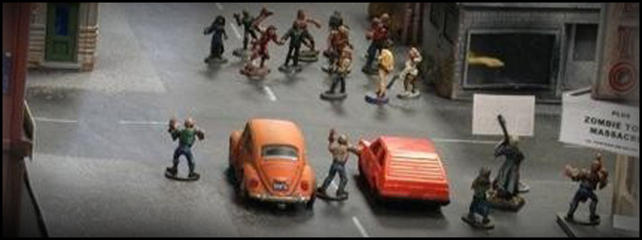
Vehicles Rules
Entering a Vehicle
A human figure ending it's turn base to base with a vehicle can entered the vehicle if it chooses. Place the figure on top of the vehicle (or to the side) to represent their position inside.
Starting a Vehicle
To start a vehicle without Car Keys a character must have the Car Thief Skill and spend 3 consecutive turns to hot wire it. If a character has Car Keys in his/her possession, the driver need only spend 1 turn starting the engine.
Vehicle Movement
Motor Vehicles can accelerate or decelerate in 10 square increments per turn (maximum speed 25) and may brake to a halt at skid rate of 1 square (forward motion) for every 5 of the vehicles current travel speed. Movement continues at the speed the vehicle ended at during the previous turn.
A vehicle may turn or deviate the forward moving portion of the vehicle to the left or right so that the sides of the vehicle's base remains completely aligned along the squares in one of four acceptable directions.
A vehicle driving backwards may only reach a max speed of 10 squares, and stopping the vehicle is automatic... i.e. there is no compulsory skid movement as the vehicle grinds to a halt.
Vehicular Combat
Drivers and Passengers inside a vehicle cannot be injured until the vehicle they occupy is destroyed... unless you decide to play the game otherwise.
- Vehicles have a 4+ Saving Throw vs. damage.
- Vehicles can take 3 Wounds before becoming wrecked.
- All human figures inside a wrecked vehicle are immediately removed from the vehicle and placed directly beside the vehicle.
- A wrecked vehicle may not be re-entered.
- A vehicle which is destroyed causes 1 wound to every occupant for every 10 squares of speed it is travelling when destroyed or wrecked.
- Zombies may not drive a vehicle.
Ramming
The driver of a vehicle may attempt to drive over enemies in his or her path. A vehicle must have accelerated to a speed of 10 or greater for the vehicle to have the possibility of injuring a figure.
If a vehicle moving at a speed of 10 or greater crosses through any enemy or friendly figure, the driver must make a vehicle attack roll against that figure. A roll of 4 or greater means the vehicle successfully struck the figure. If a vehicle ends its movement on top of a figure or figures, move those figures base to base with the vehicle on the left or right of its path. A moving vehicle does 1 wound for every 10 squares it is travelling when it impacts another figure. E.g. A vehicle moving 20 squares per turn would do 2 wounds.
If a vehicle collides with a building, another vehicle, or stationary object at a speed of 10 or greater, the vehicle comes to an immediate stop and the vehicle must make a +5 save or take damage based on its speed, if another vehicle is struck at that speed both vehicles must make a +5 save or take damage based on their speed. Impacts at speeds less than 10 cause the vehicle to stop but cause no damage to the vehicle or passengers.
Vehicle Toughness
Vehicles are treated like figures in regards to receiving any damage. Any successful hit against a vehicle may cause a wound to the vehicle if it fails it's +4 saving throw. A figure can make ranged attacks against a moving vehicle.
Figure Actions and Vehicles
A driver or passenger may not exit a vehicle moving 10 or greater without taking a wound. A jumping character is placed on the ground next to the doorway he or she jumped from. A vehicle without a driver continues in a straight course slowing naturally at 5 squares per turn unless it strikes a stationary target.
A driver cannot make a weapon attack while operating a vehicle. For passengers to make ranged or melee attacks from within a vehicle, the vehicle must be moving at a speed less than 10". Melee attacks can only be made against enemy figures in base to base contact with the window seat that figure occupies.
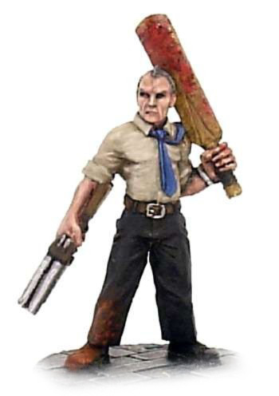
Sample/Example Characters & Stats
Name | Type | Move | Traits | Equipment | Wounds
Eve | Character | 10 | Ambidextrous, Fast Runner, Sneaky | Handgun x 2 | 2
Grant | Character | 6 |  | SMG, Handgun x2, Combat Knife, Grenades x4 | 3
Alyx | Character | 6 | Hide; Small Build; Can't Drive | Hold Out Pistol;Baseball Bat | 2
Ray Smith | Character | 6 | Leader; Special Attack | Sawn Off Shotgun; Cricket Bat | 3
Ashlee Campbell | Character | 6 | Leader | Chainsaw; Hold Out Pistol | 3
Sadie | Character | 6 | Brawler; Hide | Crossbow; Wooden Stake | 3
Kat | Character | 6 |  | Handgun; Sword | 3
Jess | Character | 6 | Jump; Hide | Hockey Stick; Handgun; Auto Shotgun; Combat Knife | 3
Ken | Character | 6 |  | Handgun x2; Bullet-Proof Vest | 3
Suzi Takahashi | Character | 6 | Brawler; Can't Drive; Tough As Nails | Machine Pistol | 4
Dr. Dionne Fletcher | Character | 6 | Medic; Ambidextrous | Hold Out Pistol x2 | 3
Problem Child Alice | Character | 4 | Can't Drive; Advance Spot Hidden; Small Build; Limited Mobility (slight limp) | Knife | 2
Tony Bolero | Character | 6 | Can't Drive | Golf Club | 3
Billie | Character | 4 | Can't Drive; Small Build; Poor Eyesight | Bare Hands | 2
Peter | Character | 6 | Small Build; Can't Drive; Sneaky | Crow Bar | 2
Katie | Character | 6 | Small Build; Can't Drive; Sneaky | Rounders Bat | 2
Elderly Person | Character | 4 |  | Bare Hands | 2
Madge Patterson | Character | 4 | Leader; Limited Movement | Pump-Action Shotgun | 3
Mad Rabbit (Alice) | Character | 6 | Hide; Advance Spot Hidden; Can't Drive | Handgun | 3
Sola | Character | 6 | Ambidextrous; Tough As Nails; Special Attack; Car Thief; Lucky; Scout | Handgun x2 | 4
Amoy De'Angelo | Character | 6 | Small Build | Rocket Launcher; Hold Out Pistol | 2
Lab Technician/Doctor | Generic | 6 |  | Bare Hands | 3
Maria | Character | 6 | Medic | Hold Out Pistol | 3
Harby | Character | 6 | Tough As Nails; Special Attack | Handgun; Knife | 4
Morgan | Character | 6 | Advanced Spot Hidden; Poor Eyesight; Tough as Nails; Scout | Handgun | 4
Zombies - Minions | Generic | 4 | Inhuman; The Blight | Claw and Bite | 1
Brain Zombie | Generic | 6 | Monster; Tough as Nails; Leader (Zombie) | Claw and Bite | 4
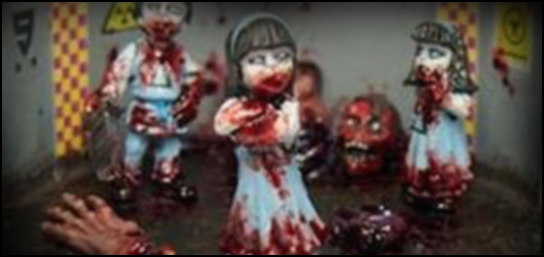
Zombie Bites & Scratches
Just a small note to players about zombies and importantly, their infectious bites and scratches. In most the classic zombie movies and books, a zombie bite or even a small scratch is enough to turn a wound lethally infectious, and will cause a victim to become ill as the zombie germs course through his or her body... eventually causing the stricken person to die, and raise again as one of the living dead.
In my zombie rules, anyone who actually dies as a result of a zombie attack will rise to become a zombie themselves within moments of death. In other words, it is death which causes the transition from human to zombie. However, a zombie bite or scratch is riddled with unclean bacteria and nasty germs, and a living person unfortunate enough to get himself injured by a zombie will take damage as per a normal attack but will only die as a result of the wound if the wounds sustained are enough to carry a miniature over the maximum damage threshold. In game terms, though a wound from a zombie might only be a tiny bite or a scratch from a fingernail, damage is sustained none the less.... This represents the unclean and generally unwholesome nature of the wound.
Wounds within Twilight can be considered a combination of scuffs, knocks, bruises, scratches, bites, and a reduction in the character's stamina and health due to sustained combat and exposure to the zombie blight. But it is only the last wound that counts, for it is this severing from life which will transform the victim into one of the soulless horde... an automaton intent on hunting down and feasting on the flesh of the living.
Game Set Up
For a basic game, you might like to allow the heroes to start the game with about 4 or 5 characters. For more figures (maybe 6 to 8) simply double the number of zombies you activate due to proximity or noise.
Heroes usually set up play along a pre determined edge of the playing area. Make sure there is no concealing terrain (which includes a wall, hedge, trees, a building, etc, etc) within 8 squares of the heroes initial set up edge.
Zombies start play without any miniatures set up on the board. Although some scenarios may require zombies to be set up in the open at the start of the game, in which case ignore what I have just said.
Zombie Activation
At the start of a game, the heroes will enter along their chosen edge. But once a hero figure moves within 8 squares of concealing terrain...pause that figure's movement and check on the Activate Zombie Table. If the result is clear, the figure may resume movement up to its full allowance. If the result reveals zombie(s), that figure cannot continue moving, and that figure's turn is considered over.
When a hero moves within 8 squares of concealing terrain throw a single die. If the result is a 5, or 6: throw again and consult the appropriate line to determine how many zombies are placed on the board. Proximity activation occurs in the game only once per terrain feature. Use the following table to determine new zombie placement when a Hero moves within 8 squares.
Terrain | Zombies
Building | 1D6-1
Single tree | 1
Group of trees (woods) | 1D6+2
Outhouse/Shed | 1D2
Wall/hedge/behind vehicle | 1D3
Behind a hill/mound/hidden area | 1D6
Placed zombies immediately move their full movement allowance towards the nearest living human (unless placed inside a building). The initial square of placement must be from a doorway/window, from a square adjacent to a tree, or the edge of a wood; from the nearest logical visible square if appearing from behind a wall/hedge, a hill, a vehicle, or located behind a hidden area. Hidden area is any location where the hero miniature has no direct line of sight.
The first time a Hero enters a building via entrance ways or windows, detach the roof (if possible) or remove the terrain piece from the table and replace it with squared graph paper, the same dimensions as the building; then place the figures appropriately inside. The hero must stop. That figure's turn is considered over.
Similar to before, throw a single 1D6 to see if the building contains any zombies. If the result is a 5, or 6. Throw another die (1D6-3 minimum 1) to determine how many zombies are placed. Place revealed zombies against an interior wall as far away from the hero who entered the building as possible. No further movement may be made this turn by these recently placed zombies. If a hero opens an outhouse or shed door and the die result is a 5, or 6; only 1 zombie is placed.
When a hero shoots a weapon (not a crossbow) throw 1D6: if the result is a 5, or 6, a single zombie is attracted to the noise. Throw for each attack die the hero rolls when making any noise. Throw for zombie activation and place fresh zombie figures after each attack die is rolled. For example, a hero who decides to use all four attacks with his Machine Pistol will roll four attack die. Check for zombie activation with each of those four shots.
Note: A good point to remember is: a hero doesn't have to throw all the attack dice his weapon allows him to make on any given turn (Exception: Dynamite, Grenade, Molotov, and Rocket Launcher, which must use all attack dice listed). The hero may decide to roll less dice and avoid making too much noise - which, of course lessens the chance of fresh zombie activation. Heroes will have to weigh the pros and cons for themselves.
It isn't only guns which threaten to bring fresh zombies into play! A chainsaw used in close combat or to cut through a barricade, explosive, a rocket launcher, or heroes attempting to break down a locked door, these things all make a lot of noise.
Zombies are placed immediately on one of the four (randomly determined) edges of the game board - as near to the shot fired as possible. Zombies placed in this manner enter the board with full movement and move towards the nearest hero figure on that edge.
All zombies who are placed from the Zombie Activation Table or because of loud noise are activated and moved immediately even though this is technically out of turn phase - though they don't get to make any attacks until it is their turn.
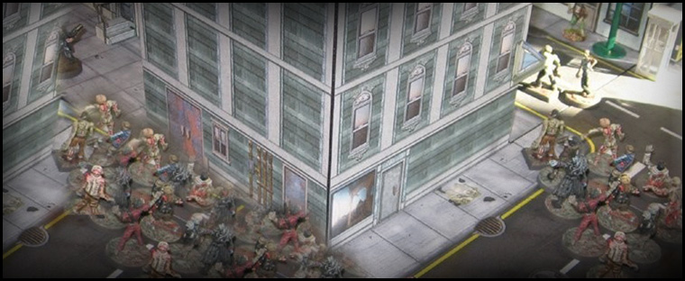
Doors, Windows & Makeshift Barricades:
Heroes may attack doors, windows and makeshift barricades using their normal attacks. However, the following special rules apply. Only one attack die can be rolled per turn... per hero, who must be standing in a square immediately facing the object (not placed diagonally).
- A door receives a saving throw of 4+
- A makeshift barricade receives a saving throw of 5+
- A chainsaw negates all saving throws
- An explosive weapon not only negates any saving throw, but also increases the To Hit roll by +2
Any successful attacks result in the obstacle being removed and no longer usable in the game.
Locking doors and windows
A hero inside a building which is clear of zombies, may state he or she is attempting to lock and bar all doors and windows within that building, provided that figure spends 3 consecutive turns doing so, during which time that figure may not conduct any action. After three turns, the figure may once again move, attack, or use any special abilities, as normal. Each additional hero reduces the time it takes to secure a building by 1 turn (minimum 1 turn).
Zombies may not enter a secured building via normal means. However (once per turn) a group of 3 or more zombies adjacent to one side of a building or who are directly behind other zombies who are themselves adjacent to the wall may attempt to break in if they can roll a 6 on 1D6. In which case, they may enter via an assumed door or window along that side of the building. Zombies may attempt to enter a building from as many sides as they choose (and check separately for each face of the building) provided there are enough zombies to meet the necessary criteria. The minimum number of zombies needed to attempt to break into one side of an outhouse or shed is 1.
Why would a hero enter a building?
Buildings potentially contain things the heroes need. When heroes (or hero) enter a building. Once they clear the building of any zombies assuming they even try, throw 2D6: if the result of that roll is 8+, throw another 2D6 and read from the table below.
If the result is a straight 2: add another 1D6-2 worth of zombies and place this fresh batch of blighted ones within the building (they are permitted no further activation this turn) as far from any heroes as possible. If not possible, place them adjacent.
- 2 Body Armour: Armour which is found maybe worn by any hero figure. Simply record that figure as now being armoured. Armour is not cumulative - i.e. cannot be worn over more armour. Roll 1D6:
  - 1-4 Bullet-Proof Vest: Knitted from interwoven layers a Kevlar, this vest is designed to protect the wearer from small arms and offers some limited protection against stabs and bites to the torso.
  - 5-6 Tactical Armour: This heavy armour is worn by military and police tactical units and is made from ceramic plates and Kevlar padding. It offers very good protection against injury but reduces a characters movement by 2 squares per turn.
- 3-6 Spare Ammo: This is generic and may be used to reload any weapons that are Out of Ammo (including the petrol for a chainsaw).
- 7-8 Medical Supplies: each medical supply that is found may be used to recover 1 wound on an injured person or self. only use once on a single figure.
- 9 Toys for the Kids: Not much practical use in the game what so ever. But makes for a good story. Imagine the pleasure on the faces of the poor kids as their protectors bring home something nice for them to play with... it is a reminder to all that life is actually worth living. All children within the game have their wounds increased by 1 because of the morale boost (for this scenario only).
- 10 Lucky Find: This can be a supply of tinned food, some bags of coal, fresh clothes, bedding, shoes that actually fit... whatever you like. Again, this is not much use in the game, but furthers the story thread. All adults still in play have their wounds increased by 1 because of the morale boost (for this scenario only).
- 11-12 Survivor(s): Add 1D2* heroes to the player's party. Good excuse to add that newly painted miniature or miniatures to your game. A roll of 6 on 1D6 adds 1D3 children or young teenagers to the survivors. Next roll 1D6 to decide survivor's temperament:
  - 1-3: survivors are friendly and join the hero group.
  - 4: survivors are neutral and will not join the player's party after this game... neither will they go out of their way to help the heroes during this game, but will defend themselves if attacked. If heroes attack the neutral survivors and kill them all, throw 2D6 again to see what valuables they are carrying (count an 11, 12 as a Lucky Find).
  - 5-6: survivors are hostile and will attack all intruding heroes and zombies alike. If the hostile survivors are killed, roll 2D6 again to see what valuables they are carrying (count an 11, 12 as a Lucky Find).
Finally, roll another die to see if neutral or hostile survivors are part of a larger settlement, and have got more friends elsewhere. If the roll is a 6, roll 1D6+2: this is the number of friends (currently off the board and out of the game) this survivor group has in reserve. The game host can extrapolate all kinds of future campaign ideas from this pool of abstract individuals.
Solo Play Mode
If you are playing this game solo, you may wish to use the following rules to determine the actions of the zombie hordes.
At the beginning of the zombies' turn, each individual zombie will move as fast as it can towards a hero or group of heroes nearest to itself. An exception to this rule is that a zombie will only move towards a previously spotted hero if the hero is within 15 squares of the thing. It would appear that zombies are more "audio" than "visual" creatures. They cannot recognize a human outside of 15 squares but will be attracted by the sound of gunfire from anywhere on the table regardless of intervening walls. They will move towards the closest fire; only moving in on a living human using line of sight if the human lies within 15 squares (about 150 feet). If a human is outside of 15 squares, the zombie will not react: (ATZ based idea).
Theoretically, a zombie may alter targets repeatedly. Remember, a zombie will always go for the nearest target. Where there is more than one target at equal distance, determine randomly which one the zombie will move towards.
In the game, once there are three zombies adjacent to a hero and presumably attacking that character, additional zombies who are within 8 squares will target the next nearest victim instead - if there is one within 15 squares.
Zombies attempting to break into a secure building can be lured away by a figure outside the building and within 8 squares. If this figure fires a weapon into the air or at one of the zombies attacking the building, throw 1D6 once - per zombie (regardless how many shots are actually fired).
- 1-4 : zombie continues attempting to break into the house.
- 5-6 : zombie moves towards the hero figure making the noise and forgets about attacking the building.
Special Thanks & Post Script
Photos by kind permission of Pappa Midnight (AL Morrison). Appreciation and huge respect also goes to Fatgoblin (aka Kai Teck) for his amazingly high standard of miniature modelling. Thank you both for allowing me to grace the pages of my rules with your art.
The rest of the rules are mine, and I have copyright stamped across it simply to encourage others to respect my work. But please feel free to take any part of my work and re-write it into your own games... with my complements. In fact, these rules are a combination of hard work and effort not only by me, but those who inspired and came before me: not least, Ed Teixeira, Josh (Zombie Smith), and all the other pioneers in the genre.
Enormous thanks TO YOU ALL.
© 2014, Stephen A Gilbert

