INRADIC
The Gentle Art of Imagi-Nation Gaming
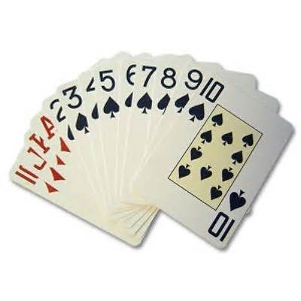
Wargaming has changed so much since I first discovered it some forty or more years ago; and the hobby as I grew up knowing it... is now called `retro` or `old school gaming`. Strange really as to me it`s all just roots of where I started. I`m not even sure I like the hobby that much as a whole as it exists in its development today. Without going into the wherefores and whys (there are already enough blogs and articles in existence describing exactly what the changes are) I can clearly state that the manual you are now reading stems from my personal delight in simple rules... lots of imagination to fill in the gaps – even mid game sometimes; and to this day, I still get most of my inspiration from the early pioneering days of the hobby (Tony Bath, Donald Featherstone, Terrance Wise, etc). Thus, the manual you are reading is a culmination of my way of doing things: based on half a lifetime of wargaming... especially solo gaming. The In-game Numerical Random Action Decision Indicative Calculator (or INRADIC for short), explores gaming at its best... through simple yet robust rules, designed to allow you to get on with your games with a real `hands on` approach. Instead of needing to fight pages and pages of way over complicated rules; INRADIC lets you fight imaginary battles without all the fuss. It’s time to get back to the basics and have fun playing toy soldiers... as opposed to being just rules lawyers.
In truth, I probably owe a lot of my somewhat warped, jaded, and free spirited drive to the guys over at the Yahoo group “The Society of Daisy” for their lateral thinking and alternative approach to almost everything game related. Indeed, I only really wrote this game for myself to help me with my own table top games and semi-rpg`s; but somewhere along the way, I decided to let others share in the fun I was having (because, believe it or not, this simplistic little game is actually very user friendly, and highly enjoyable to play).
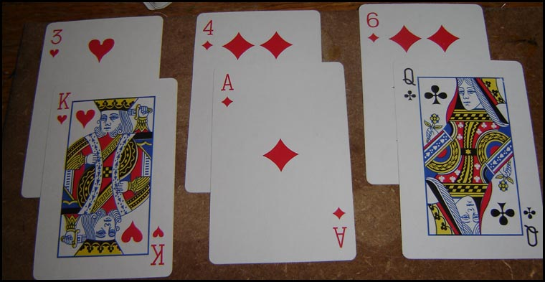
Ranged Weapons Uses a normal pack of playing cards: every 5 figures from the same unit draw 2 cards. Fractions* below five still draw 2 cards (except Multi-Shot figures, who draw 4 cards); heroes, leaders, etc draw 3 cards: example, fractions {i.e. 1, 2, 3, or 4 men} would draw 2 cards. A 6 man unit plus a hero would thus draw 7 cards: 2 for the first five figures and another 2 for the additional sixth figure, and 3 more for the hero.
* whether from ranged attack or melee, fractions (under five) fighting alone can never score more hits than the number of figures actually making the attack... unless firer is using multi shot or is a hero/leader or lone Monster type.
- Musket/Rifle: Range: 16 inches.
- Bow/Sling: Range: 12 inches.
- Pistol/Revolver: Range 10 inches.
- Multi-shot Weapon (Machine Gun etc): 14 - personal): 20 inches - crew); Draw the top 4 cards from the deck for each Multi-Shot armed piece firing... 8 cards if crew manned MG under half range.
- Artillery: Range: 40 inches; Draw the top 3 cards from the deck per gun firing. The target and all adjacent miniatures take the same hits as the 3 card initial draw. If 2 picture cards are drawn, a machine gun or artillery is out of ammunition on a D6 roll of 4+ (the weapon does not get to fire that turn). The weapon is resupplied on a subsequent turn when an ammunition wagon/pony etc spends a turn within 3 inches of the gun and crew. If the roll is a 1 or 2 the weapon only jams this turn.
- Thrown Explosives (per unit): Draw 1 card (ignore picture cards and draw again), the number drawn must be between 1 and 6 to land on target: anything over this represents shot deviation or a failure to explode (1D6: 1 undershot, 2, 3 left: 4, 5 right: 6 overshot). Pull a card from the deck and divide by 2 (round down) for the distance of deviation; a picture card drawn means the shot fails to go off at all. Anyone within 2 inches of the explosion point must draw 2 cards (unless behind substantial cover) to see whether they take any hits.
Save Cards Every time a hit card is drawn (numbered and picture cards apply), the target unit may attempt to negate the hit by drawing a card and placing it below the hit card. If the save card (any suit) equals or exceeds the hit card, the attack for that hit card is ignored. Targets that are in cover against ranged weapons draw 2 save cards at a time against each attack. Targets over half range also draw 1 additional save card.
Movement (Optional Rule) Three times during a game, the player controlling the British may be made to interrupt a unit action. A unit (unit heroes/leaders included) that starts a turn more than 12 inches from a friendly staff officer (these are usually the mounted officers... not the flag bearers, buglers or sergeants) that is attempting to move or fire can be made to take a D6 roll. If this roll yields a 1 or 2: that unit may not perform the action it was about to take this turn whether that be to move or shoot (cannot stop a unit about to melee). A unit may be targeted twice in a turn: e.g. stopped from moving then stopped from shooting.
Ignore the above rule if playing a skirmish level game with only a few units per side.
Human movement is usually 4 inches per turn (3 inches if slow). Very fast humans may move 5 inches per turn. Mounted figures and large animals move 8 inches (elephant) or 10 inches (horses/camels) per turn. Conveyances can move up to 20 inches a turn, and can accelerate/ decelerate 5 inches a turn. If a conveyance wants to make an immediate stop, it will skid 1 inch for every 4 inches of its current speed that turn. Passengers in a conveyance may place an additional save card against ranged attacks (counts as cover). A vehicle has 1 to 10 hit points (car 3: lorry 5: armoured car/train 10 etc). Ranged attacks against a conveyance are nominated at the passengers and the vehicle {unless the Game Host states otherwise}.
Men must try to stay within 5 inches of at least one other member of the same unit at all times (unless commanded to split from the main body by their commanding officer). The Games Host must keep an eye open to ensure this discipline is maintained where humanly possible. Single figures units do also exist: e.g. a single sentry or a henchman guard patrolling alone at night, etc.
Melee This is similar to drawing cards for ranged attacks. The exact weapon type used is not important... the number of cards a figure or group of figures represents is what counts. When large close combat fights take place (with multiple base to base combatants), pool all the attack cards together... and lay them out in a line.
- Every 5 Cavalry draw 3 cards in melee. Every 5 Mounted Infantry draw 2 cards in melee.
- Every 5 Infantry (natives/irregulars) or Artillery Crew draw 1 card in melee.
- Every 5 Veteran Infantry (soldiers) draw 2 cards in melee.
- Every 5 Weak Monsters draws 1 card in Melee.
- Every 5 Monsters draw 2 cards in Melee.
- Every 1 Tough Monster draws 3 cards in Melee.
- Every 1 Elite Monster draws 4 cards in Melee. Every 1 Huge Monster draws 5 cards in Melee.
Combat Classing Your Collection
Weak Monsters might include: Goblin kin/Native Tribesmen/Zombies. Monsters might include Hobs/Chaotic Fanatics/Gorillas/ Hungry Wolves/ Horrifying Living Skeletons/Lost Dwarf Nation/Mythical Atlantis Elves. Tough Monsters might include Ogres/Living Trees/Raptors/Cthulhu Monstrosities. Elite Monsters might include Trolls/Elephants/Giants Huge monsters might include T-Rex/King Kong/Demons
In Melee, every 5 men get the number of cards indicated above. Fractions below five draw card like 5 men units do. In addition, Heroes draw 3 cards in melee. Side Kicks, Generals, Leaders (NCO`s), and Bad Guy Bosses draw 2 cards in melee. Buglers and Flag Bearers draw 1 card in melee. Each Figure breaking away from melee base contact with an enemy is subject to a free (1 card) attack.
Every time a hit card is drawn, the target unit may attempt to negate the melee hit by drawing a card and placing it half over the hit card. If the save card (any suit) equals or exceeds the hit card, the attack for that hit card is ignored.
Hits always remove 1 figure or one artillery crew... when all artillery crew are removed as casualties, the gun is inoperable. Should you need to give an artillery piece a hit rating during a scenario: give a gun 3 hit points.
Once hits and saves have been calculated, the good guys ("Self") always get to choose which enemy or enemies receive hits. When it is a bad guy dealing out the hits (i.e. the enemy the player is trying to win against) then the good guys ("Self") always chooses which own figures receive hits... in any combination he/she likes. Shuffle the pack of cards often.
Get into the habit of doing this, to keep the game interesting. Every 5 men and of course fractions (or 1 artillery and crew) in cover get 1 extra card in melee.
In Addition: targets of melee attacks that are in cover occupying a building, or who are uphill of the enemy; and on the first turn of a melee if they are defending a wall, hedge, or in trees, etc. draw an additional save card each melee.
Five of Diamonds & Jokers
A Five of Diamonds always represents a fumble. It represents an automatic failure. A Joker always represents a glorious success. Only good guys get to use the joker card.
Hit Points for Leaders & Monsters
I suggest "Self " main characters start a game with 4 hits: NCO`s, officers and side-kicks 2 each.
Bad Guy main characters 3.
I suggest the following for Monsters:
Weak Monsters 1 hit point each Monsters 2 hit points each Tough Monsters 3 hit points each Elite Monsters 5 hit points each Huge monsters 7 hit points each
When an individual figure is hit due to ranged attacks or melee the owning player should mark the figure in some way to show it has been damaged. When hits take a figure to `0` the piece is removed from play.
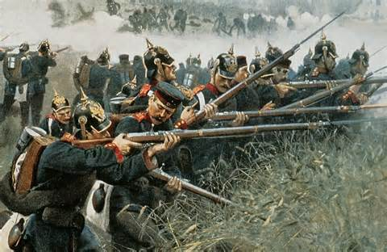
Morale
Units Will Check Morale When...
1: it receives a casualty from enemy ranged attacks.
2: it receives 2 casualties in melee.
3: it sees (own) Bugler, Flag Bearer, Corporal, NCO or Officer killed
4: it sees a friendly unit rout (within 10 inches & line of sight).
5: When charged by an enemy at least equal size.
6: Attacked (melee) in the flank or rear by an enemy half (or larger) own size.

Unit Size & Morale:
The morale die or dice used to determine morale results must match this initial starting number of figures in the unit. For example, a unit of five figures will always throw a D5: ten figures will throw a D10 to determine morale results. A unit of fourteen figures will always throw a D10 and a D4... and so on.

To Pass a Morale check.... roll equal to or lower than the number of figures remaining in the unit.

If a morale check is failed.... the affected figures retire/rout a double move away from the enemy (ignore terrain: but loose 1 man in five if forced to cross water)... and must make another morale check at the beginning of the next turn to see if they stop running away.

A unit cannot attempt to rally while being pursued by an enemy or while within a charge move of an enemy unit. A unit eligible to rally may only attempt to do so providing there is a bugler, flag bearer, NCO, or an officer present with the unit. Men who rally will do so adjacent this leader figure {group the miniatures all around the officer who is rallying them}.

Use the pursuit table below to determine potential pursuit.

Pursuit

Die{1D6}
Pursuing Unit

Commoner/Peasant never pursue
Militia/Irregular/Native Contingent can pursue on a 1 (but only for the first turn)
Trained 4, 5, 6 can pursue (and stop) if player desires
Well Trained 2, 3, 4, 5, 6 can pursue (and stop) if player desires
Veteran always... if desired
Fighters(Fanatics) always (can be declined on a 1): 5, 6 needed to halt a pursuit

Morale Modifiers for Varying Quality of Units:

When forced to make morale checks, remove or add 1 to 3 pips from the die or dice throw total (Pips added to the dice total is bad for morale: pips that reduce the dice total is a good thing):

Commoners/Peasants (very poor, with little or no training) +2 to the morale dice

Militia/Irregulars/Native Contingent (little experience) +1 to the morale dice

Trained (average soldiers of this period) ~

Well Trained (above average fighting experience) -1 from the morale dice

Veteran (experienced campaigners) -2 from the morale dice

Fighters (fanatics) -3 from the morale dice

Situation modifiers:
-1 each die if uphill of an engaging enemy.
-1 each die if self is behind/defending soft or makeshift cover. -3 each die if self is behind/defending hard cover.
+1 each die if attacked by an enemy on the flank.
+2 each die if attacked by an enemy on the rear.
Hits on Heroes & Leaders (Optional extra rule): Any `Ace` card drawn (shooting or melee) has a chance of killing someone important from among the ranks. Each Ace drawn has a chance of hitting/killing a Bugler, Flag Bearer, NCO, Hero, or Staff Officer. Roll a D6 and read below. Example: if an NCO is present, a roll of 3 means that piece takes a hit (or a bugler or flag bearer instead, if the attacker wishes). Anything higher than the roll cannot be targeted.
1 Bugler 2 Flag Bearer 3 NCO 4 Hero 5 Staff Officer 6 General in Charge
